Air Force JROTC
FL-881
Developing leadership, followership and teamwork.
Demonstrating discipline and personal responsibility.
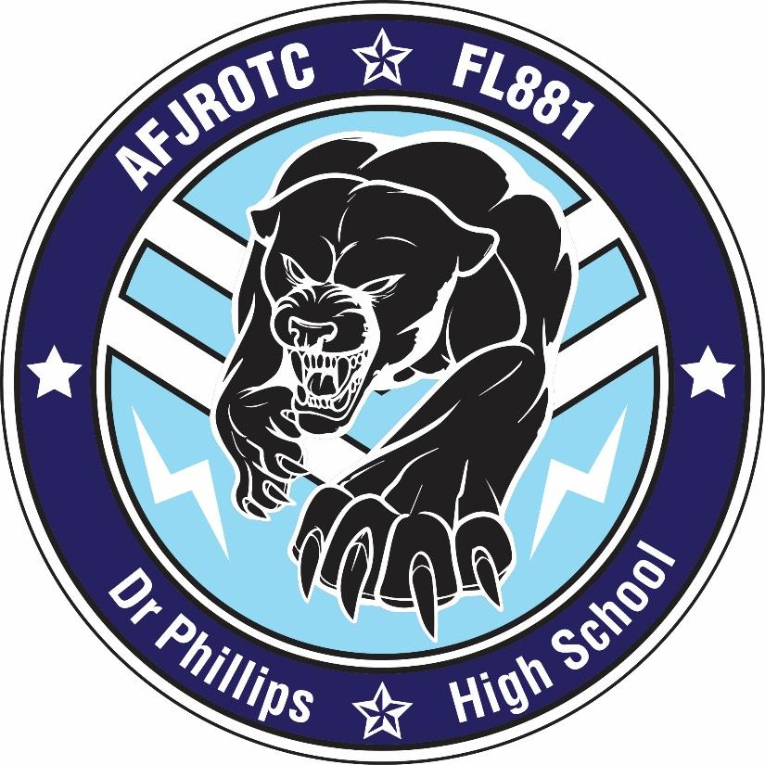

Dr. Phillips High School
“Never Less Than the Best”

CADET GUIDE
August 2016

NAME: Squadron:_______

MISSION
The mission of Air Force JROTC is to develop citizens of character dedicated to serving their nation and community.

HONOR CODE
I will not lie, cheat or steal, nor tolerate those who do.

CORE VALUES
Integrity First
Service Before Self
Excellence in All We Do

AIR FORCE SONG
Off we go into the wild blue yonder,
Climbing high into the sun.
Here they come, zooming to meet our thunder,
At 'em boys, give 'er the gun!
Down we dive, spouting our flames from under,
Off with one hell-of-a-roar!
We live in fame or go down in flame.
Nothing will stop the U.S. Air Force!

Table of Contents
CHAPTER 1: HISTORY, MISSION AND OBJECTIVES
CHAPTER 2: GRADING PROCEDURES
CHAPTER 3: CADET CONDUCT
CHAPTER 4: AFJROTC FL-881 Form 341
CHAPTER 5: COURTESY, BEHAVIOR AND CHEATING
CHAPTER 6: CADET APPEARANCE STANDARDS
Male Cadet Standards.
Female Cadet Standards
CHAPTER 7: WEAR OF THE UNIFORM
Uniform Requirements for Male Cadets
Uniform Requirements for Female Cadets
Uniform Inspection Guidelines
Insignia, Badges and Ribbons
Headgear
Lightweight Jacket
Service Dress
Blue Shirt
Airman Battle Uniform (ABU)
Tying A Tie
CHAPTER 8: SALUTING RULES
CHAPTER 9: CO-CURRICULAR ACTIVITIES
CHAPTER 10: AWARDS AND DECORATIONS
National Awards
Air Force JROTC Sponsored Awards
Badges and Headgear
Local Recognition:
CHAPTER 11: ACTIVITIES AND FIELD TRIPS
CHAPTER 12: WING CHAIN OF COMMAND
CHAPTER 13: CADET PROMOTION SYSTEM
ATTACHMENTS
ATTACHMENT 1: OPEN RANKS INSPECTION
ATTACHMENT 2: DRILL TERMS
ATTACHMENT 3: DRILL COMMAND SEQUENCES
ATTACHMENT 4: GENERAL MILITARY INFO
ATTACHMENT 5: ACTIVE DUTY MILITARY RANK INSIGNIA

CHAPTER 1: HISTORY, MISSION AND OBJECTIVES

- HISTORY

Air Force Junior Reserve Officer Training Corps (JROTC) can track its heritage to a program founded in 1911 in Cheyenne, Wyoming, by Army Lt Edgar R. Steevers. Lieutenant Steevers was assigned as an inspector-instructor of the organized military of Wyoming. During his assignment, he envisioned a noncompulsory cadet corps comprised of high school students. His program was aimed toward making better citizens.
The National Defense Act of 1916 authorized a junior course for non-college military schools, high schools and other non-preparatory schools. The Army implemented JROTC in 1916. Public Law 88-647, commonly known as the ROTC Vitalization Act of 1964, directed the secretaries of each military service to establish and maintain JROTC units for their respective services. The first Air Force JROTC programs were opened in 1966.
(The) purpose of Junior Reserve Officers’ Training Corps [is] to instill in students in United States secondary educational institutions the value of citizenship, service to the United States, personal responsibility, and a sense of accomplishment.” (10 USC Sec 2031)
Air Force JROTC (AFJROTC) is a continuing success story. From a modest beginning of 20 units in 1966, AFJROTC has grown by leaps and bounds. The AFJROTC program enrolls approximately 102,000 cadets, employs more than 1,700 instructors and operates units in 48 states, the District of Columbia, Puerto Rico, Italy, Germany, Belgium, Netherlands, United Kingdom, Japan, Korea, and Guam. The AFJROTC program positively influences our country by helping one student at a time. Comprised solely of active duty Air Force retirees, the AFJROTC instructor force is helping to form tomorrow’s nation by educating proud and patriotic cadets—tomorrow’s leaders.

Our unit, FL-881, Dr. Phillips High School, was established 1 August 1988.

- MISSION AND OBJECTIVES

The mission of AFJROTC is to develop citizens of character dedicated to serving their nation and community. AFJROTC offers positive role models, a place to belong, excel, and be rewarded. Additionally, AFJROTC stresses and teaches the important values of citizenship, self-esteem, self-respect, service to community, pride in belonging, self-discipline, and personal, family and social responsibility. Cadets have a positive educational experience in which they are encouraged to graduate and pursue higher educational opportunities. A strong message of saying “NO” to drugs is part of the program.

There are several advantages for AFJROTC graduates who voluntarily pursue military service after high school graduation. For example, if the student chooses to enlist in the military, they may qualify for advanced enlistment. AFJROTC cadets also have additional opportunities to pursue service academy appointments and ROTC scholarships not available to other college applicants.

CHAPTER 2: GRADING PROCEDURES

This course will follow the standards of the United States Air Force JROTC Program and Orange County Public Schools. In addition, cadets will meet the personal grooming, appearance and haircut standards; meet the established standards of attitude, behavior, and courtesy; maintain an acceptable standard of academic and leadership achievement; and respond positively to cadets assigned to leadership positions within the cadet corps.

Grades from the Aerospace Science portion of the course count 40% of the AFJROTC final grade. The Leadership Education portion of the grade counts 40% of the final grade. The Wellness portion of the program counts for the remaining 20% of the final grade.

Grades will be computed in accordance with standard district grading policy.

MAJOR GRADES | DAILY GRADES
Uniform Wear | Class Attendance, Preparation & Participation
Tests, Community Service | Quizzes
Parades, Unit Activities, Special Events | Homework/Classwork/Bellwork

GRADING SCALE: As set by the Orange County School Board:

Grade Percentage Required
A 90 and above
B 80 - 89
C 75 - 79
D 70 - 74
F 69 and below

UNIFORM WEAR: Uniform wear is a large part of the Air Force JROTC program. ALL cadets are required to wear the appropriate “Blues” each Tuesday, from the start of the school day until released. Make-up day for excused absences on uniform day is the first day of return, without a reminder. Failing to wear the uniform all day will result in a “0” (zero) grade for that uniform day. Cadets are required to wear their issued Physical Training uniforms on Fridays unless otherwise directed. Failure to turn in uniforms by the end of the course/year will result in a financial obligation being submitted.

HABITUAL NON-WEAR OF THE UNIFORM AND FAILURE TO MAINTAIN STANDARDS WILL RESULT IN A FAILING GRADE AND DISMISSAL FROM THE PROGRAM.

TESTS: Tests will be a comprehensive assessment of all material taught since the last test. These tests will cover the concepts taught in any portion (AS, LE, Wellness) of the AFJROTC curriculum.

COMMUNITY SERVICE: Cadets will have multiple opportunities to perform Air Force JROTC sponsored community service during each semester. Cadets will receive a grade each semester based on the number of hours served.

CURRICULUM IN ACTION (CIA)/FIELD TRIPS: Throughout the year, cadets will have opportunities to participate in school-sponsored activities that serve as an extension of the AFJROTC curriculum. These trips are for a grade and may include, but are not limited to, the Orlando Veteran’s Day Parade and the Military Ball. Cadets must be in good academic and disciplinary standing to participate.

CLASS ATTENDANCE, PREPARATION AND PARTICIPATION: Today’s workforce does not earn a paycheck unless they show up ready for work. Cadets earn grades commensurate with their class participation and effort. Cadets who are not present or prepared cannot participate fully in class. This is especially key to drill and physical fitness. Class preparation includes cadet adherence to proper grooming standards as outlined in the Air Force Instruction and school dress code.

QUIZZES: Daily quizzes will be administered throughout the course. Quizzes will cover a small amount of material. The content will be established by the Senior Aerospace Science Instructor (SASI) or the Aerospace Science Instructor (ASI).

HOMEWORK/CLASSWORK/BELLWORK: Assignments are due at the beginning of the class period, unless otherwise directed or the cadet has an excused absence that day. For excused absences, the assignment will be due on the next class day that the cadet is present. Assignments not turned in on the due date because of an unexcused absence will receive a “0” (zero) grade for that assignment.

CHAPTER 3: CADET CONDUCT

- Roll Call:
- Cadets will enter the classroom quietly and go to their seats. They will place books and backpacks under the desk. When the 2-minute warning bell rings, each cadet will assume the position of “Parade Rest” by his/her assigned seat.

- When the tardy bell rings, the Squadron Commander will call the room to “Attention,” then will give the command “Parade Rest”. The respective Flight Chiefs will start calling roll. When the cadet’s name is called, they will come to the position of “Attention” and answer “Here Sir/Ma’am”, regardless of the Flight Chief’s relative rank. After the next cadet’s name is called, they will return to the position of “Parade Rest”.

- When roll is complete, the Squadron Commander will call the squadron to “Attention”. The respective Flight Chiefs will report in to the Squadron Commander by saluting and saying: “Sir/Ma’am, all cadets are present and/or accounted for.” Then the Squadron Commander will report in to the SASI/ASI in the same manner. Once the SASI/ASI has returned the salute, the class will be given further instructions.

- Tardy cadets will enter quietly and assume the position of parade rest near the door. When recognized by the class leader or instructor, the tardy cadet will assume the position of attention and follow the directions given by the class leader or instructor.

- When any school administrator enters a classroom, the first cadet recognizing the administrator will call the room to attention.

- When the End-of-Class bell rings, or at the signal of the instructor, the assigned Class Leader will call the flight to “ATTENTION”. Cadets will come to the position of ATTENTION at the side of their desk and wait for further instructions. The Class Leader will check that all trash is picked up and the desks are aligned. The Class Leader will salute and report to the SASI/ASI ‘’The Flight is Ready for Dismissal’. After the SASI/ASI states “Dismiss the Flight”, the Class Leader will “DISMISS” the flight. Cadets can then retrieve their personal belongings and depart the classroom.

- All cadets will be expected to follow all rules listed in the OCPS Code of Conduct while attending school or school-related activities. In addition, the following rules apply in the AFJROTC classroom and area.
- Remove headgear before coming indoors and do not place it back on your head until you are going outdoors.
- Do not bring food or drink into the classroom, except for water in a closed container.
- NO CHEWING GUM in the classroom! Get rid of chewing gum you may have in your mouth prior to entering the classroom. Do not put gum in your mouth while in the classroom.
- Unauthorized personnel are not allowed in any classroom or office.
- Wearing hats or sunglasses indoors is prohibited.
- No horseplay in the AFJROTC areas.
- Maintain self-control and your self-respect at all times.
- Instructors will demand courteous and disciplined behavior. They will treat all students firmly, fairly, and impartially.
- CELL PHONES: Cell phone policy is in accordance with OCPS district instructions. Cell phones must remain out of sight with the ringer off. Cadet cell phones will not be charged during class. Any student who refuses to put away their cell phone when asked will be considered insubordinate and will receive additional disciplinary consequences.
- CLASS BEHAVIOR: The nature of the AFJROTC mission, as well as its high visibility within the school and community, requires it members to adhere to higher standards than might be found among the student population. Inappropriate behavior, in or out of uniform, is prohibited while participating in AFJROTC. This behavior includes, but is not limited to, consuming alcohol, drug abuse, tobacco use, horseplay, public displays of affection, fighting, disparaging remarks, insubordination, disrespect, verbal threats and physical attacks.
- Comply with instructions given to you by the cadet in charge when the instructor is not present.
- Be on time. Don’t be late to class, scheduled events, practices, etc.
- Remain in your seat unless given permission to move about the room. Remain professional; do not sit on desks, tables, trash cans, etc.
- Always use the trash can to dispose of trash. If you see trash on the floor, clean it up.
- Bring all materials to be used for class; such as Cadet Guide, Staff Guide, pens, pencils, and notebook or paper.
- Once instruction has begun, talking is prohibited, except with permission from the instructor.
- Be attentive when someone else is speaking. Listen respectively to the speaker/presenter, or fellow cadets, when they are speaking.
- Turn in projects and assignments on time.
- Do not lay your head on the desk or sleep in class; stand up in the rear of the classroom.
- Tell the instructor if you are ill!! Go to the nurse or stay home.
- Profanity will not be used in or around the AFJROTC area.
- Hazing or conduct designed to demean another cadet will not be tolerated.
- School rules prohibiting Public Displays of Affection (PDA) will be rigidly enforced in the classroom, cadet area, and at any AFJROTC activity.
- Grooming, primping, and applying cosmetics or lotions will not be done in class.
- DISENROLLMENT: Cadets may be disenrolled at any time during the academic year to maintain the morale and discipline of the unit. Disenrollment from Air Force JROTC is recommended by the SASI and approved by the principal. Disenrollment is a last resort, preceded by substantiated documentation and corrective counseling. A cadet may be disenrolled/withdrawn from Air Force JROTC the following reasons:
- Failure to wear the Air Force uniform as required by the SASI/ASI.
- Failure to maintain acceptable standards (including uniform and personal
- grooming).
- Inaptitude or indifference to training.
- Misconduct/disciplinary reasons.
- Failure to remain enrolled in school.
- Excessive truancies or absences.
- Involvement with alcohol, tobacco, drugs, or other activities generally
unacceptable in the school/community.
- Any other reason deemed appropriate by the SASI and/or principal.

CHAPTER 4: AFJROTC FL-881 Form 341
The AFJROTC FL-881 Form 341 is used to document both positive and negative feedback for cadets. The use of the AFJROTC FL-881 Form 341 applies to all cadets in FL-881. Its purpose is to maintain good order, discipline, respect and proper standards within the cadet corps. They can be submitted by Cadet Wing Staff members of FL-881 or the faculty/staff of Dr. Phillips High School.
NOTE: The purpose of a 341 is for documentation of a cadet’s excellence or discrepancy in the Wing--NOT to attack the cadet. All 341’s should be filed away in the appropriate Squadron Binder for reference during Cadet Review Boards (promotions, awards/decorations, or disciplinary actions, etc.).
            - There are a few guidelines to follow for the proper use of the AFJROTC FL-881 Form 341:
- All cadets will carry at least two AFJROTC FL-881 Form 341s at all times, in or out of uniform.
- Cadets receiving a AFJROTC FL-881 Form 341 will be able to offer written rebuttal to comments on the AFJROTC FL-881 Form 341.
- Any completed AFJROTC FL-881 Form 341s will be used to determine the need for additional actions, such as promotions/demotions, Cadet of the Month or job assignments.
- The Wing Training officer will monitor the AFJROTC FL-881 Form 341 Program.
            - EXCELLENCE. When filling out an AFJROTC FL-881 Form 341 for Excellence, document on the AFJROTC FL-881 Form 341 what they did to show they deserve an “Excellence 341.” If the Flight Chief is writing an Excellence 341, have the Sq/CC approve it and initial next to the Squadron name (shown on the example). After three Excellence 341s, the cadet may be subject to a Cadet Review Board for recognition and/or promotion.
            - DISCREPANCY. Using an AFJROTC FL-881 Form 341 for a Discrepancy is a last resort to correct unacceptable performance, behavior, or standards. These recommendations may be submitted for misconduct, customs and courtesies violations, dress and appearance violations, failure to fulfill cadet responsibilities, etc.
            - Before submitting a “Discrepancy 341,” make sure these steps have been completed:
              - Cadet behavior has been reflected on the Weekly Performance Sheet, or equivalent.
  - Flight Chiefs have mentored the cadet on how to correct behavior
  - The Flight Chiefs have given positive feedback to address negative behavior, if warranted. For example, “You are doing a good job compared to last week, please keep it up.”
  - Cadets have been referred to their Sq/CC for counseling.
  - Wait at least 24 hours to fill out another Discrepancy 341 to give the cadet an opportunity to correct his or her behavior/actions.
- If the Flight Chiefs and Squadron Commander have completed these steps, the Discrepancy 341 will be filed. This will ensure that both the Flight Chiefs and the Reported Cadet have taken steps to solve the problem. After three Discrepancy 341s, the cadet may be subject to a Cadet Review Board to discuss his/her actions and possible demotion or disciplinary actions.

CHAPTER 5: COURTESY, BEHAVIOR AND CHEATING
Military courtesy in the cadet corps is the expected behavior, and is necessary for mutual respect among cadets. It requires polite and considerate behavior at all levels. In the cadet corps, there are certain ceremonial procedures and specific acts of kindness, respect, and politeness used to demonstrate military courtesy. It is important that cadets understand them and get into the spirit of this behavior. Courteous behavior and a cooperative spirit are essential to a successful cadet corps.
- SALUTING - The salute is a form of military greeting. It is customary for cadets to salute the SASI at all times, and, when in uniform, to salute cadet officers of a higher rank. Saluting is not required while under covered common areas or walkways. Cadets will also salute when reporting to a person in charge of a formation, even if the person in charge of the formation is not a cadet officer. If you are outdoors, the U.S. Flag is saluted during the National Anthem and while it is passing when carried in a parade.
- USE OF TITLES - Civilians are addressed as Mr., Mrs., Ms., or Miss. Military personnel are addressed by their rank. Cadets may be addressed as Mr., Miss, or by their cadet rank. Such as, “Mr. Jones,” “Miss Smith,” “Cadet Sergeant Jones” or “Cadet Smith”.
- SIR OR MA'AM - It is a sign of respect to those in authority to address them or respond with “Sir” or “Ma'am.” Such responses reflect long-established military courtesies, which will soon become a habit, even though you may find it difficult at first. Cadets are expected to respond in this manner without hesitation. This practice outside of Air Force JROTC will produce pleasant and favorable results, especially from parents and teachers.
- CONVERSATION ETIQUETTE - Using words like “please” and “thank you” are important. Do not interrupt others when talking. Respect the right of others to have opinions that may differ from yours.
- BEHAVIOR - Aggressive behavior, such as verbal abuse, pushing and shoving, kicking, and throwing objects, will not be tolerated, even when the initial intent is in a joking manner. All cadets will practice a “HANDS OFF” policy to prevent any misunderstanding. Additionally, there will be no touching or “public displays of affection (PDA)” anytime or anywhere, when you are in uniform, and at all times in the Air Force JROTC classroom, in any of the Air Force JROTC lab areas (i.e. drill pad, PT location), and any other time you are under SASI/ASI supervision. Cadets who are repeat offenders of this policy will be disenrolled from the program.
- RESPECT FOR AUTHORITY - Responsible and successful citizens develop respect for authority. People in positions of authority are continually challenged to earn that respect.
- LEARN TO THINK BEFORE SPEAKING - Try to do things yourself rather than asking questions that are not necessary. For example, questions such as “Where do I place my rank insignia?” or “Do we wear uniforms next Tuesday?” are not necessary because the answers to these questions are available in your classroom.
- MEETING A BOARD – Report to the designated location when directed. Assume the position of attention outside the door. Knock ONCE and wait to be recognized. Once recognized, state: “Cadet_______requests permission to enter.” When permission is granted, open the door and proceed in a military manner (square corners) to center yourself on the board members; salute and say, Cadet_______reports as ordered.” Report out and depart the room in the same manner.

CHAPTER 6: CADET APPEARANCE STANDARDS
Because you wear the official uniform of the United States Air Force, any objectionable behavior or appearance in public can create an unfavorable opinion toward the AFJROTC program, Dr. Phillips High School, and the United States Air Force. On the other hand, proper conduct, actions, and appearance will create a favorable public reaction and enhance the image of your Cadet Corps. Therefore, as an Air Force Junior ROTC cadet, you must constantly strive to present a neat, clean, and well-groomed appearance.
  - The following are Air Force grooming standards that cadets are required to meet. Although somewhat conservative, it is the standard in the Air Force. Failure to meet these standards will influence your grade, may result in your failing the course, and can lead to your disenrollment from Air Force JROTC.

Table 5.1 Clothing and Accessory Standards
To present the proper military image | Will be
Clothing | Neat, clean, pressed, proper fit, in good condition, zipped, snapped, or buttoned.
Footwear | Shined, in good repair.
Watch | Conservative.
Bracelet | Conservative, no wider than one inch, do not present safety hazard.
Rings | A maximum of three at one time.
Earrings | MALES MAY NOT WEAR EARRINGS OR EAR STUDS while in uniform.  Small, conservative, diamond, gold, white pearl, or silver. Spherical, pierced, or clip. Fit tightly without extending below the earlobe. (EXCEPTION: connecting band on clip earrings)  Only one earring per ear.
Body piercing jewelry | Not allowed.
Eyeglasses/sunglasses | Free of ornamentation on frames/lenses. Conservative, clear, slightly tinted, or photosensitive lenses in formation. Conservative lenses and frames outdoors (faddish styles and mirrored lenses prohibited.) No sunglasses in formation. Not worn around the neck or on the head, or hung from pocket.
Necklaces | Concealed under collar or undershirt.
Pencils/pens | Concealed.
Ear Phones | Not Allowed!
Cell Phone Use | Only use while standing still. Walking and Talking is not allowed!!

Table 5.2 Grooming Standards
Item of Grooming  (M-Men, W-Women) | Will be/have | Will not
Beards (M) | Clean cut, neat | Be worn except for health reasons when authorized by a commander on the advice of a medical officer. If commander authorizes, members keep facial hair trimmed not to exceed ¼ inch in length. Individuals granted a shaving waiver will not shave any facial hair. Commanders and supervisors will monitor progress in treatment to control these waivers.
Wigs and Hairpieces (M) | Their medical records documented to wear a wig or hairpiece to cover baldness or disfiguration. Other male personnel do not wear wigs  or hairpieces. Good quality and fit properly.
Hair, Overall Standard  (M & W) | Clean, well-groomed and neat. If dyed, will be of a natural hair color. | Contain excessive amount of grooming aids. Hair will not touch eyebrows when  groomed or protrude below the front band  of properly worn headgear. EXCEPTION:  Hair will be visible in front of the women's  Flight cap. Will not be worn in extreme or fad styles such as braids (men), fad coloring, or design cuts.
Hair Style (M) | A tapered appearance on both sides and back, both with and without headgear. A tapered appearance is one that when viewed from any angle outlines the individual's hair so that it conforms to the shape of the head, curving inward to the termination point. Block cut permitted with tapered appearance. | Be worn in an extreme or fad style or in  such a way that exceeds length or bulk  standards or violates safety requirements.  Will not touch the ears and only closely cut or shaved hair on the back of the neck may touch the collar. Will not exceed 1 1/4  inches in bulk, regardless of length and not exceed 1/4 inch at the termination point. Will not contain or have any visible foreign items attached to it.
Hair Style (W) | Styled to present a professional  appearance. Plain and conservative pins, combs, headbands and barrettes similar to the individual's hair color permitted to keep hair in place. | Be worn in an extreme or fad style or  violate safety requirements. Will not  extend in length on all sides below an  invisible line drawn parallel to the ground at the bottom edge of the shirt collar at the  back of the neck. Will not exceed 3 inches  in bulk or prevent proper wear of headgear. Will not include hair ornaments such as ribbons or jeweled pins.
Mustache (M) |  | Extend downward beyond the lip line of the  upper lip or extend sideways beyond a  vertical line drawn upward from the comer  of the mouth. (This does not apply to  individuals having shaving waivers.)
Sideburns (M) | Neatly trimmed and tapered in the same manner as the haircut. Will be straight and of even width (not flared) and end in a clean-shaven horizontal line. | Extend below the lowest part of the exterior ear opening. (This does not apply to individuals having shaving waivers.)
Wigs and Hairpieces (M & W) | Conform to the same standards required for natural hair, be of good quality, and fit properly. | Exceed limits stated for natural hair.
Cosmetics (W) | Conservative and in good taste
Nail Polish (W) | Conservative in color and in good taste. | Contain any ornamentation or multi colors
NOTE: The items listed represent the most common appearance issues. The list is not all inclusive.

Male Cadet Standards.

- FACE - Will be clean shaven. Beards will not be worn except for health reasons when authorized by the SASI upon written recommendation of a physician. Mustaches must not extend downward below the lip line, nor extend on either side beyond the corner of the mouth.

- SIDEBURNS - Must be neatly trimmed and tapered in the same manner as the haircut. Must not extend below the lowest part of the exterior ear opening.

- HAIR - Will be neat, clean, trimmed, and present a groomed appearance. Must have a tapered appearance on the sides and back. The thickness may not exceed 1/4 inch at the termination point. A block cut is permitted as long as a tapered appearance is kept. Hair may not touch the ears, and only the closely cut or shaved hair on the back of the neck may touch the collar. The overall bulk may not exceed 1 1/4 inch thick. It must not contain any visible foreign items attached to it.

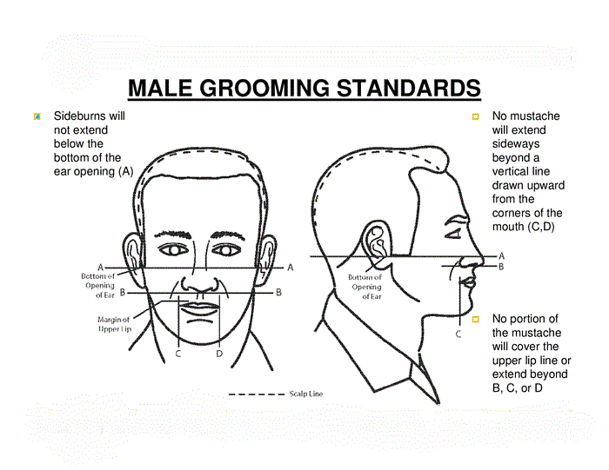
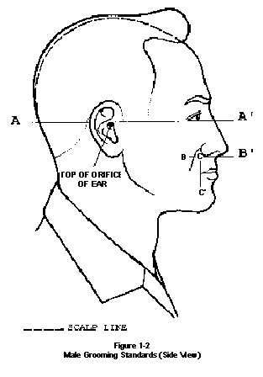
Line A –Hair does not extend below lowest opening of the ear.

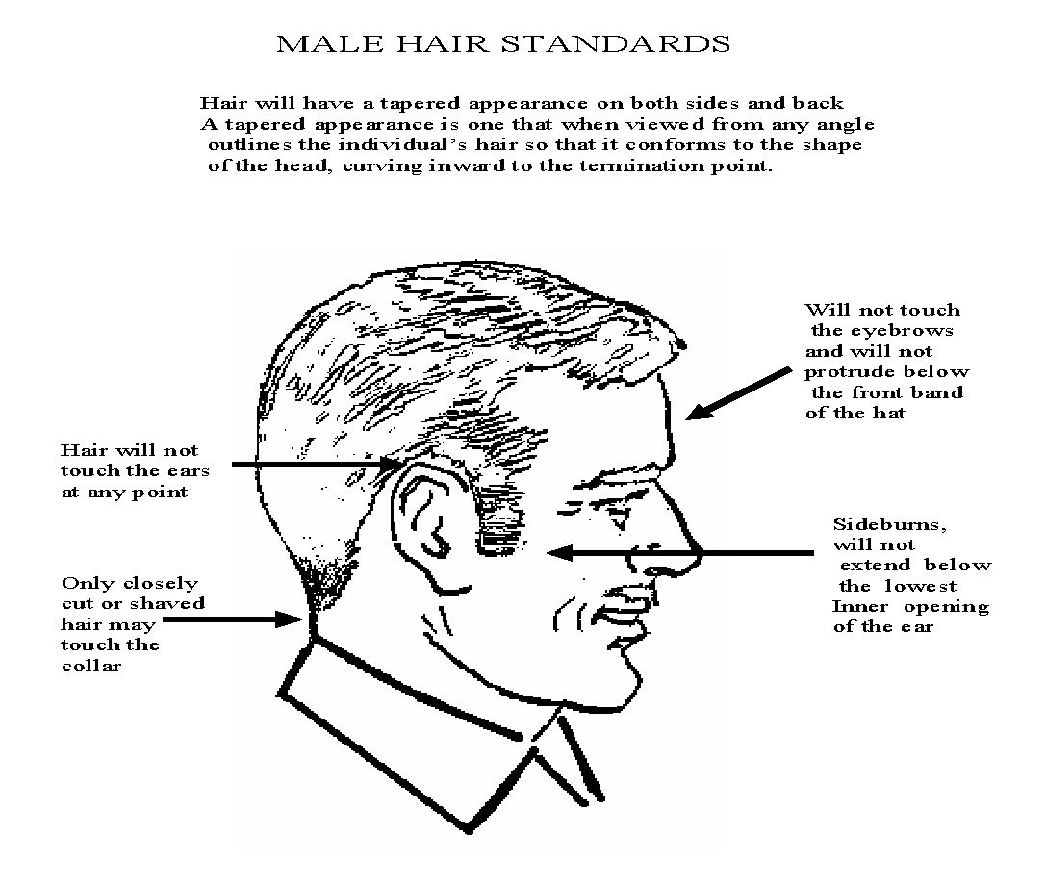

Female Cadet Standards

- HAIR - Must be styled to permit proper wear of Air Force cap. Hair must always be clean, neatly arranged, and styled to present an attractive feminine appearance. May not exceed 3 inches in bulk. Ornamentation such as ribbons, jeweled pins, etc. is not permitted. Plain pins, combs, and barrettes, similar in color to the hair, may be worn to keep hair in place. Hair may not hang below the bottom edge of the coat/blouse collar at the back of the neck.

- COSMETICS - Polished nails will be all the same color and will closely match the wearer’s skin tone. All cosmetics must be conservative and in good taste.

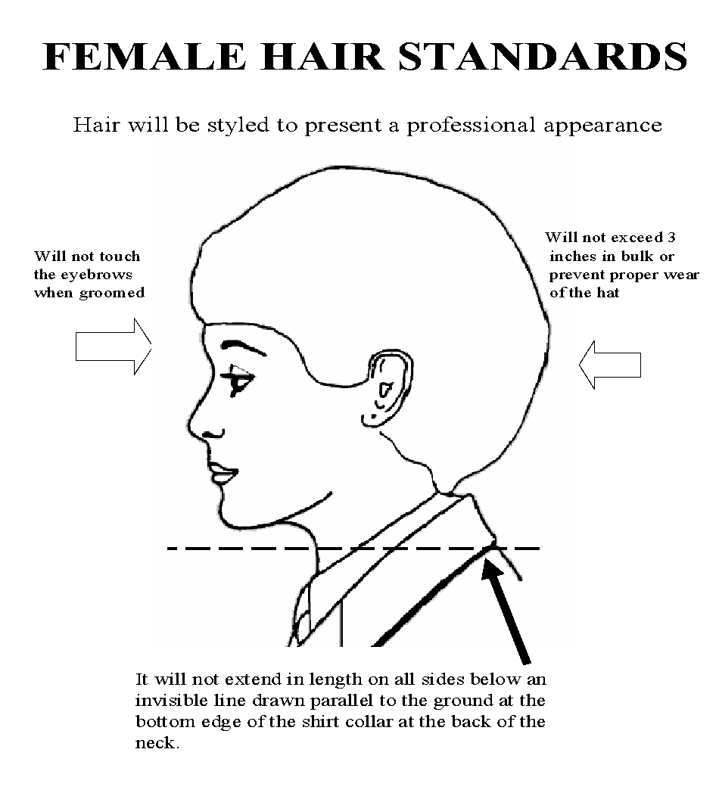

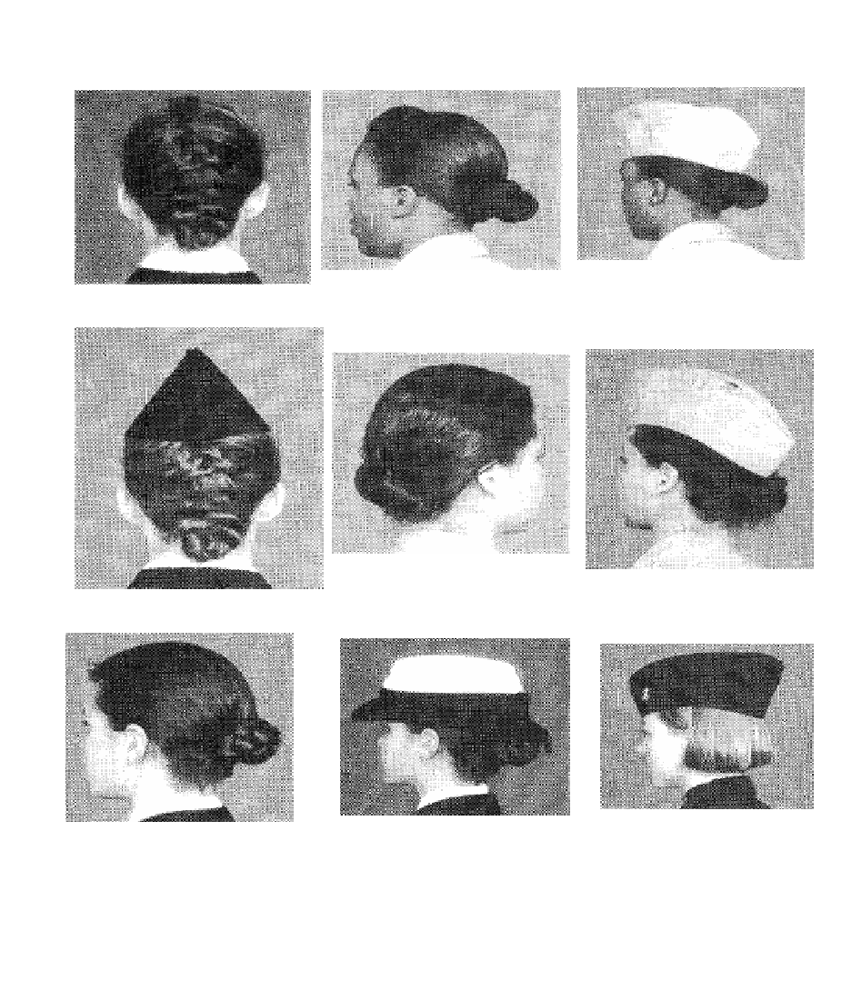

CHAPTER 7: WEAR OF THE UNIFORM
The reputation of the United States Air Force as a professional military organization is known worldwide. The uniform you wear is the same uniform worn by active duty Air Force personnel. Since the uniform is a symbol of their reputation, each cadet at Dr. Phillips High School is expected to wear it properly. Proper wear of the uniform is illustrated in the figures and tables located on the following pages.

NOTE: When turning in the uniform at any time, items will be properly dry-cleaned and ready for re-issue. Failure to dry-clean items will result in an obligation for cleaning costs of $30.00.

  - Tuesday of each week is uniform wear day, unless you are instructed otherwise. The uniform must be worn all day. If you are absent on Uniform Wear Day, the uniform must be worn to makeup the grade on the 1st day back in school, without a reminder. The uniform may be removed for classes that require special attire (Physical Education, etc.), but must be put back on after that class is complete. If you are observed out of uniform without permission obtained from the SASI/ASI, you will receive a zero (0) for the grade that day.
  - Only authorized uniform items will be worn. Never mix uniform items with civilian clothing, as this will result in a zero (0) for the grade that day. An example of this would be the wearing of a civilian coat/jacket with the uniform.
  - When the flight cap is not being worn, it may be tucked under the belt on the wearer’s left side between the first and second belt loops (cap will not fold over belt or be visible below service coat).
  - Wear all rank, ribbons, and insignia as shown in the diagrams on the following pages.
  - All pockets will remain buttoned. Hands should be kept out of uniform pockets.
  - Your “GIG” line is the line formed by the shirt button edge of the shirt, the edge of the belt buckle that is opposite the tip, and the fly of the trousers. The “gig” line should always be kept straight, check it frequently.
  - Trim loose strings, fuzz, and frayed seams on the uniform.
  - Do not carry bulky items in the pockets which distort the appearance of the uniform.
  - Replace missing buttons promptly. Like most of the insignia, buttons on the blue coat are oxidized silver. Do not attempt to shine these items.
  - Develop the habit of carrying books and other objects in the left hand to free the right hand for saluting.
  - Never place any articles under the epaulet of the jacket or shirt.
  - A V-neck T-shirt with sleeves must be worn by all cadets in uniform. The T-shirt must be plain, white, and clean, and it must not show at the open shirt collar or under the sleeves. Wear a properly fitted under shirt to avoid these problems.
  - All ribbons and insignia are fastened with metal clutches.
  - Hitchhiking, performing hard labor, engaging in sports activities, etc., while wearing the uniform is not permitted.
  - No cadet should ever purchase an optional uniform item without first checking with an Aerospace Science Instructor to verify the item is suitable.
  - All uniform items (except shoes, socks, name tag and ribbons) must be turned in at the end of the school year. You will be required to pay for all lost items. The cost of each item is on the uniform issue form.

Uniform Requirements for Male Cadets
- The flight cap is worn with the front crease towards the lower center of the forehead (two finger widths above the right eyebrow). When worn in this manner, the crest of the cap will be fully extended without a protruding tip at the back. If your cap does not fit in this manner, it is either too large or too small. See Logistics personnel to trade for a proper fitting cap. Caps will be worn at all times outside the classroom or building. The cap does not have to be worn while under any covered common areas or covered walkways.
- The belt is threaded through the loops to your left. When buckled, only the metal tip of the belt should show through the buckle. The adjustable belt clamp is to change the length of the belt for a proper fit.
- The shoes will be laced to the top and shined at all times. Corfam shoes are an optional personal purchase item for AS II, AS III, and AS IV cadets. The issue shoes will be worn at Cadet Leadership Course (CLC) and when directed by the Instructors.
- The socks must be black. No other colors are authorized.
- Shirts should be laundered after each use. The short sleeve blue shirt is worn with the collar open or buttoned with a tie. The shirt tail is pulled down into the trousers tightly and tucked at the sides. The only creases on the shirt are down the sides of the sleeves. No items (other than a pen or pencil, which does not stick out of the pocket) will be carried in the shirt pockets. A plain white, V-neck T-shirt with sleeves must be worn under the shirt. Wearing the tie is optional except you must wear it when you are wearing the service coat, or the long sleeve blue shirt.
- The blue trousers must be dry cleaned. The bottom of the trouser legs will touch the shoes so as to cause a slight break in the front trouser crease. The back of the trouser leg should be about 7/8 inches longer than the front. No cuffs are worn on the military uniform trousers. You need to obtain permission to alter the leg length and waist size of the trousers. The left rear pocket of the trousers will be buttoned at all times. Articles carried in the pockets will not be visible. Glasses cases, key chains, etc. will not be worn on the belt.
- The service coat must be dry-cleaned. The coat is worn buttoned. The coat may be removed while in a classroom. The coat will be donned and buttoned before leaving the classroom.
- Service caps are optional as directed by Instructors. These may be purchased at the cadet’s personal expense. Service caps will be worn with the appropriate AFJROTC insignia. Caps will have a plain bill. Service caps will not be worn at CLC.
- The name tag will be centered, resting on, but not over the edge of the pleated pocket on the wearer’s right.
- Ribbons are optional on the blue shirt (mandatory on the service dress). If worn, all ribbons and devices will be worn. If worn, ribbons will be centered, resting on, but not over the edge of the pleated pocket on the wearers left.

Uniform Requirements for Female Cadets
- The flight cap is worn slightly to the right with the vertical crease of the cap at the center of the forehead in a straight line with the nose. The cap should be worn about 1 to 1 1/2 inches above the eyebrows. Caps will be worn at all times outside the classroom or building. The cap does not have to be worn while under any covered common areas or covered walkways.
- The belt is threaded through the loops to your right. When buckled, only the metal tip of the belt should show through the buckle. The adjustable belt clamp is to change the length of the belt for a proper fit.
- Leather low quarter shoes will be issued. They will be laced to the top and shined at all times. They will be worn by all AS I female cadets. Corfam shoes and/or plain toe black pumps with a defined heel may be worn as an optional personal expense item by AS II, AS III, and AS IV cadets. The issue shoes will be worn at CLC and when directed by the Instructors.
- The female blouse should be laundered after each use. The shirt tail is pulled down into the trousers tightly and tucked at the sides. The only creases on the shirt are down the sides of the sleeves. A plain white, V-neck T-shirt with sleeves must be worn under the blouse. The collar tab (a.k.a. tie tab) is optional, except when you are wearing the service coat or the long sleeve blue shirt.
- The blue pants must be dry-cleaned. You need not obtain permission to alter the length and waist size of the pants. The bottom of the slacks will barely rest on the front of the shoes with a slight break in the crease. The back of the slacks will extend about 7/8 of an inch longer than the front. Do not alter the width of the pants leg.
- The service coat must be dry-cleaned. The coat is worn with the buttons buttoned. The coat may be removed while in a classroom. The coat will be donned and buttoned before leaving the classroom.
- Service caps are optional as directed by Instructors. These may be purchased at the cadet’s personal expense. Service caps will be worn with the appropriate AFJROTC insignia. Service caps will not be worn at CLC.
- The name tag will be centered, even with or up to 1½ inches higher or lower than the first exposed button on the wearer’s right.
- Ribbons are optional on the blue shirt (mandatory on the service dress). When worn, all ribbons and devices will be worn. When worn, center ribbons on wearer’s left, parallel with ground. Align bottom of the ribbons with the bottom of the name tag.

Uniform Inspection Guidelines
A uniform inspection will be conducted each week. Initially, the SASI/ASI will instruct you on the proper wear of the uniform and then inspect you using the system of deductions from a perfect score for wear of the uniform. Your Flight Chiefs will conduct subsequent inspections. Repeated offenses will result in higher deductions.
NOTE: A Service Dress Coat, if worn, will be inspected in place of the blue shirt, but a lightweight jacket will not be.

Males
-50 Hair (needs haircut/unnatural color/designs/braids/cornrows/dreadlocks/fad style)
-30 Headgear Missing
-20 Sideburns (length/appearance)
-20 Unauthorized Facial Hair
-20 Unauthorized Jewelry (per piece) (watches allowed)
-20 Nametag—Service Dress (centered on the wearer’s right between the sleeve seam and lapel and the bottom of the name tag will be parallel with bottom of the ribbons)
-20 Ribbons—Service Dress (centered, resting on (but not over) the edge of the welt pocket)
-10 Nametag—Blue Shirt (centered on right pocket flap)
-10 Ribbons—Blue Shirt (serviceable; correct order; centered, resting on, but not over the edge of the pleated pocket on the wearers left)
-10 Under Shirt (not a V-neck, missing, torn, not white, dirty, etc.)
-10 Black Socks (missing/not black)
-10 Shoes (not polished, stains, dirt, edges need cleaning)
-5 Tie (dirty or missing)
-5 Belt and Buckle (not shined, gig line off, etc.)
-5 Button (per missing button)
Subtract an additional 5 points for each:
Missing, dirty or unauthorized uniform items not addressed above (i.e., hat brass, officer rank/shoulder boards, jackets, shirts, etc.)
Talking and/or misbehaving in inspection formation
Incorrect response to an inspection question

Females
-50 Hairstyle (does not allow proper wearing of headgear, extends below collar, unnatural color, dreadlocks/fad style, hairband doesn’t match hair color, etc.)
-30 Headgear Missing
-20 Unauthorized Jewelry (per piece) (watches allowed)
-20 Lipstick (unauthorized color(s))
-20 Fingernails (unauthorized color(s) or designs and/or designer nails)
-20 Nametag—Service Dress (centered on the wearer’s right between the sleeve seam and lapel and the bottom of name tag will be parallel with bottom of ribbons)
-20 Ribbons—Service Dress (centered, resting on (but not over) the edge of the welt pocket)
-20 Nametag—Blue Shirt (centered, parallel to ground, even with to 1 ½ inches higher or lower than the first exposed button)
-10 Ribbons—Blue Shirt (serviceable; correct order; centered, parallel to ground, bottom of the ribbons aligned with bottom of name tag)
-10 Under Shirt (not a V-neck, missing, torn, not white, dirty, etc.)
-10 Black Socks (missing/not black)
-10 Shoes (not polished, stains, dirt, edges need cleaning)
-5 Tie Tab (dirty or missing)
-5 Belt and Buckle (not shined, gig line off, etc.)
-5 Button (per missing button)
Subtract an additional 5 points for each:
Missing, dirty or unauthorized uniform items not addressed above (i.e., hat brass, officer rank/shoulder boards, jackets, shirts, etc.)
Talking and/or misbehaving in inspection formation
Incorrect response to an inspection question

Insignia, Badges and Ribbons

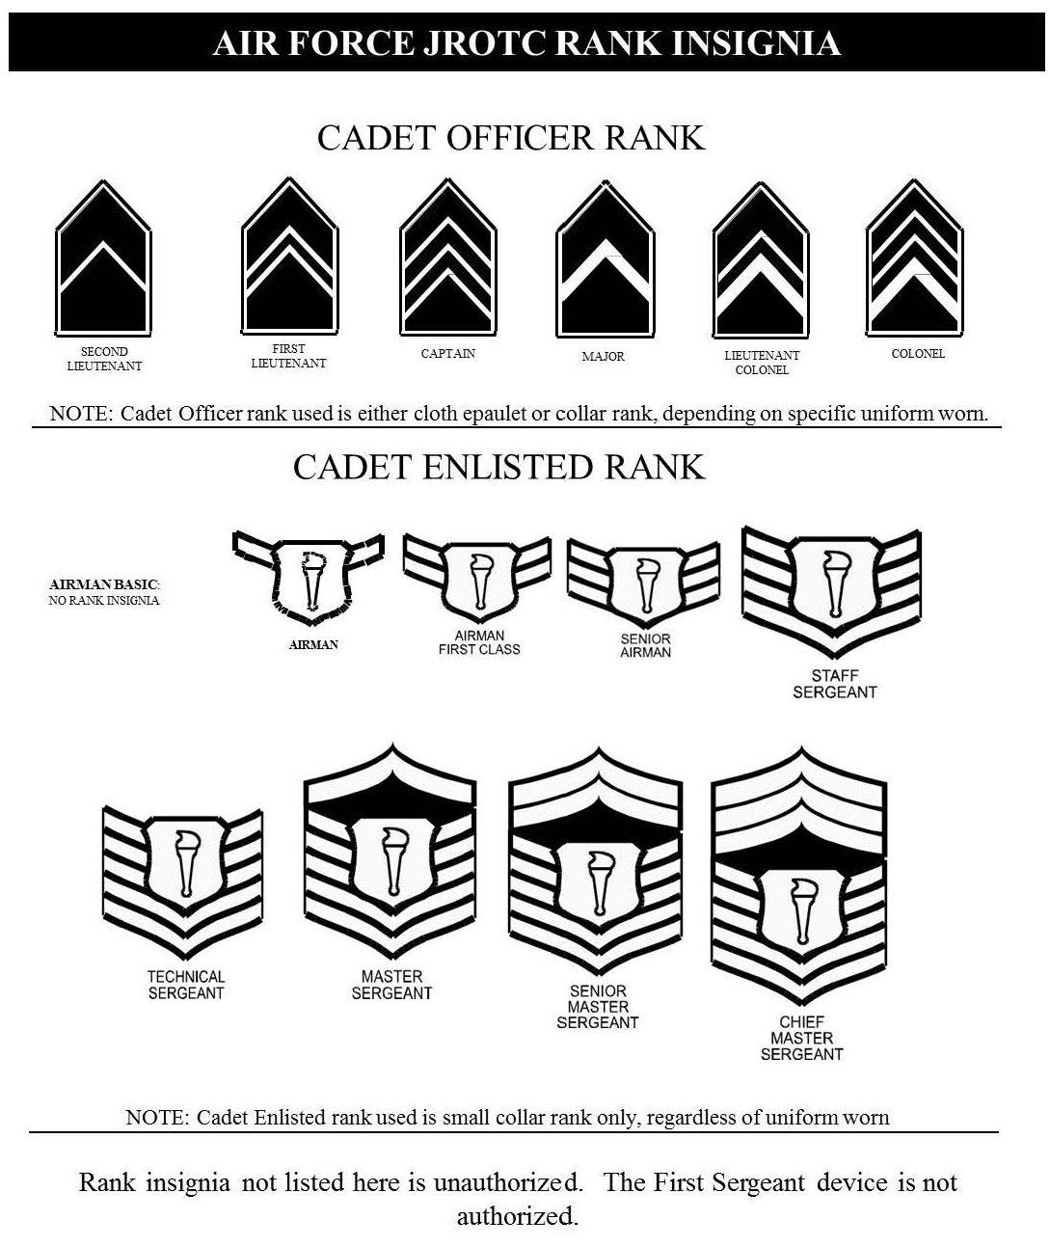

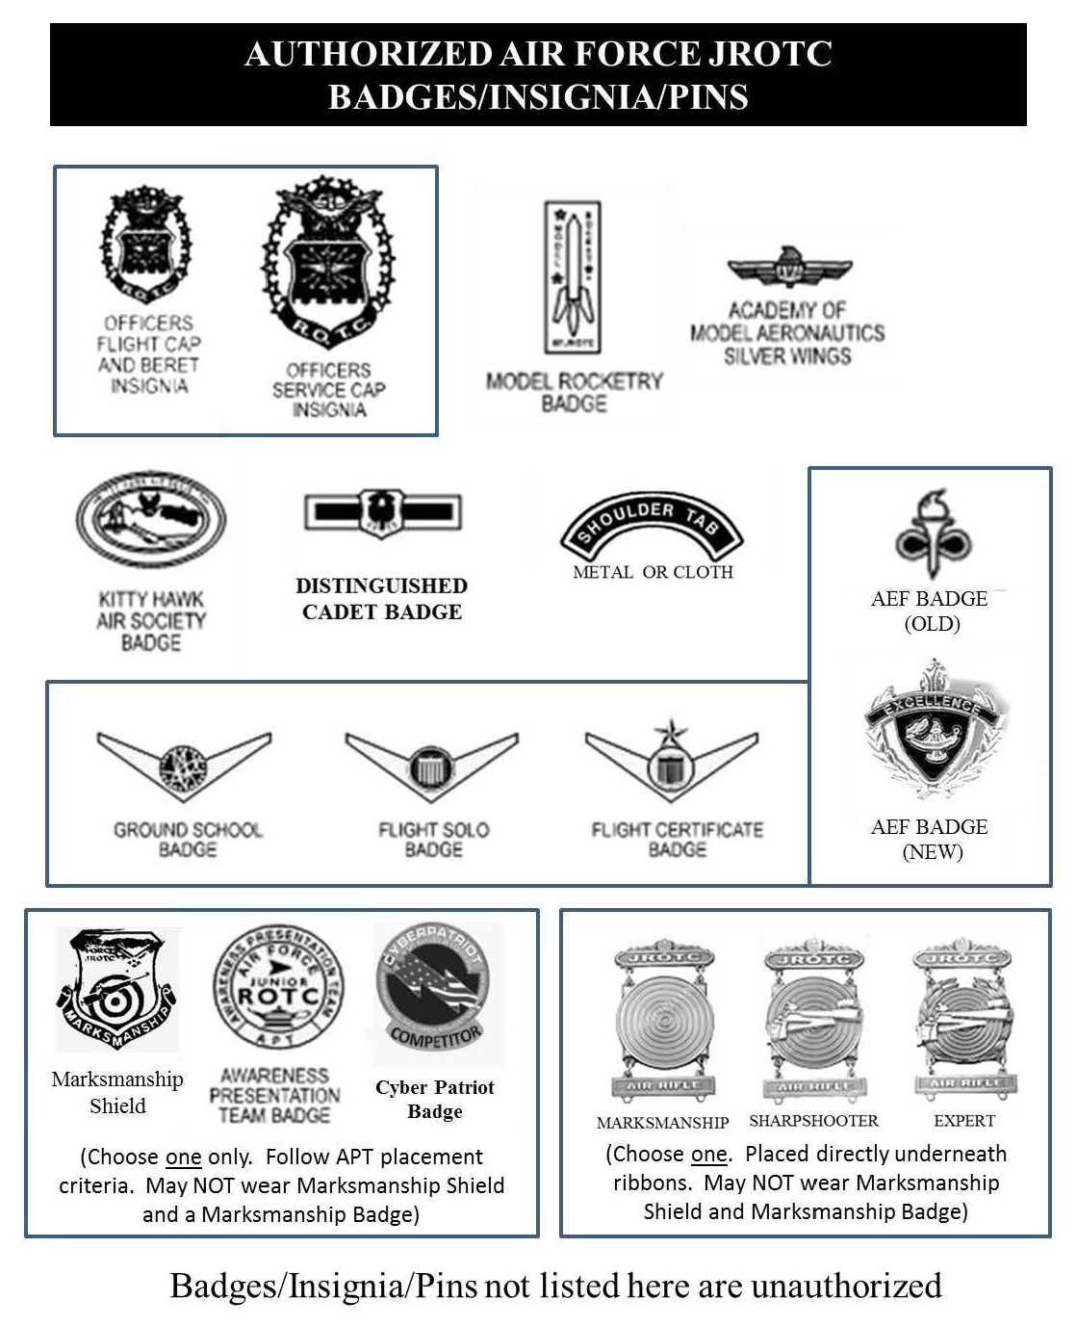
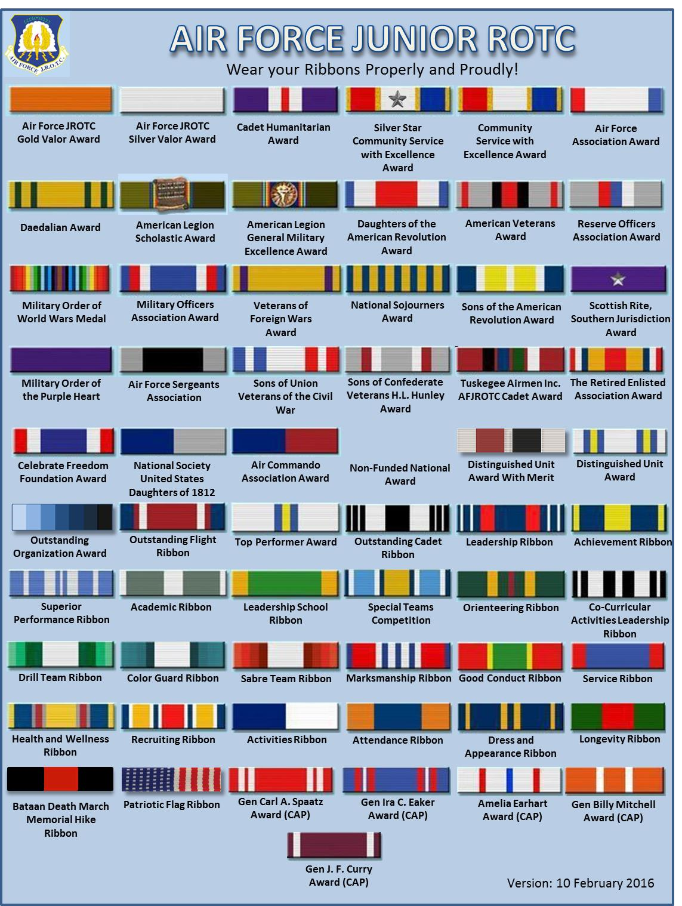

A bronze oak leaf represents an additional award of the basic ribbon. A silver oak leaf represents 5 bronze oak leaves. Wear a maximum of 4 oak leaves on each ribbon. Place clusters as shown above. If a second ribbon is worn, due to lack of room for oak leaves, the second ribbon is worn to the left of the original ribbon.

Single oak leaf mounting Two oak leaf mounting

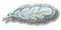

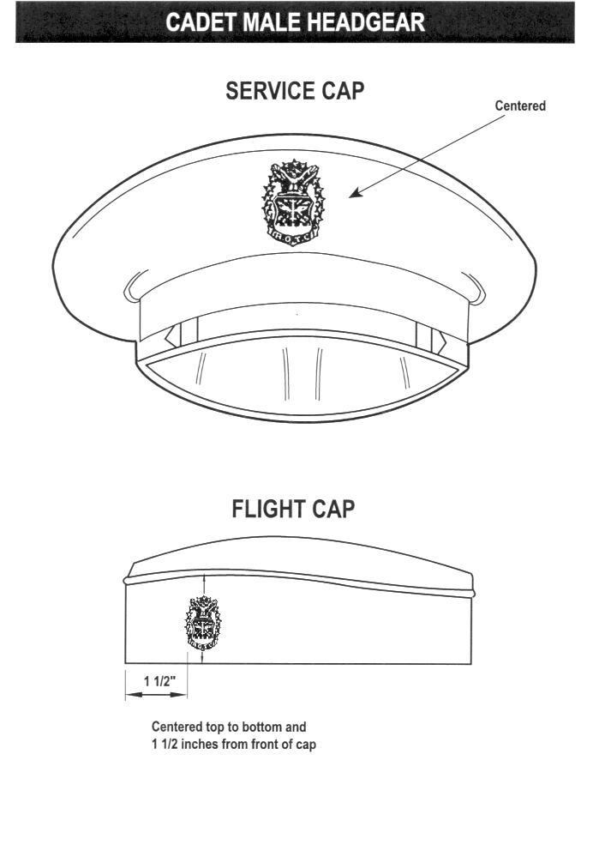
Headgear

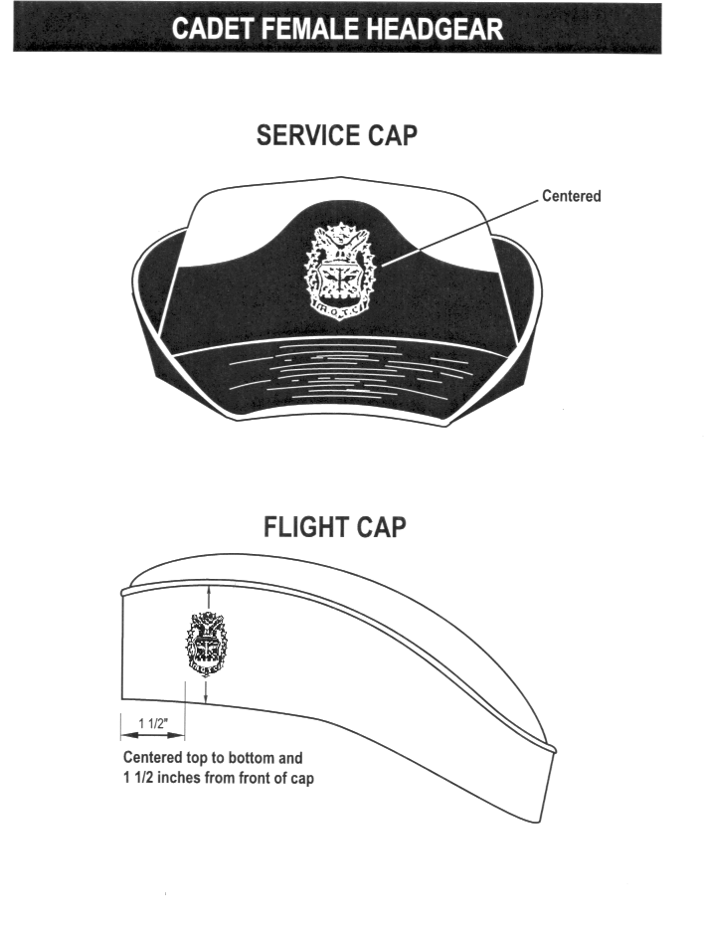

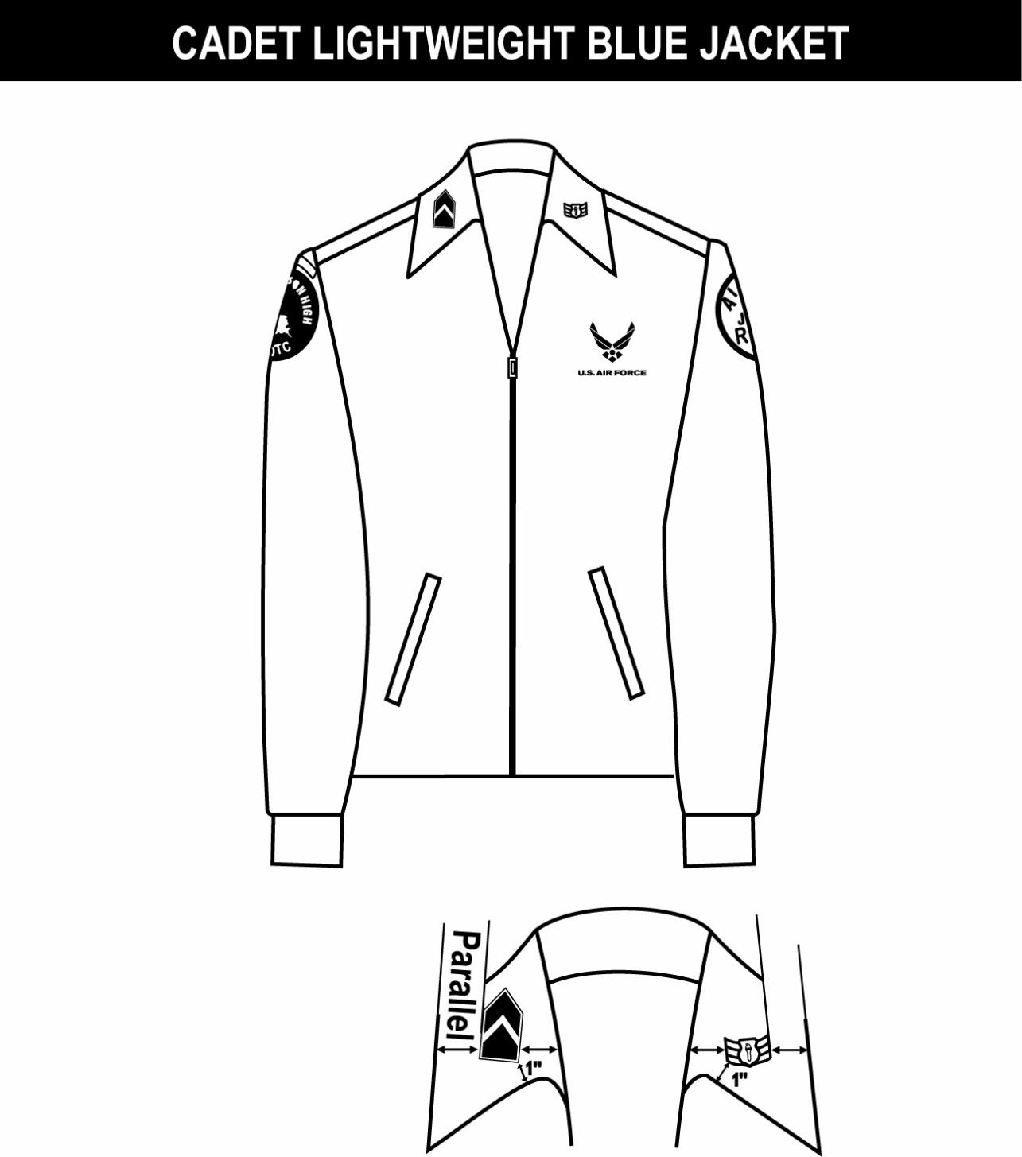
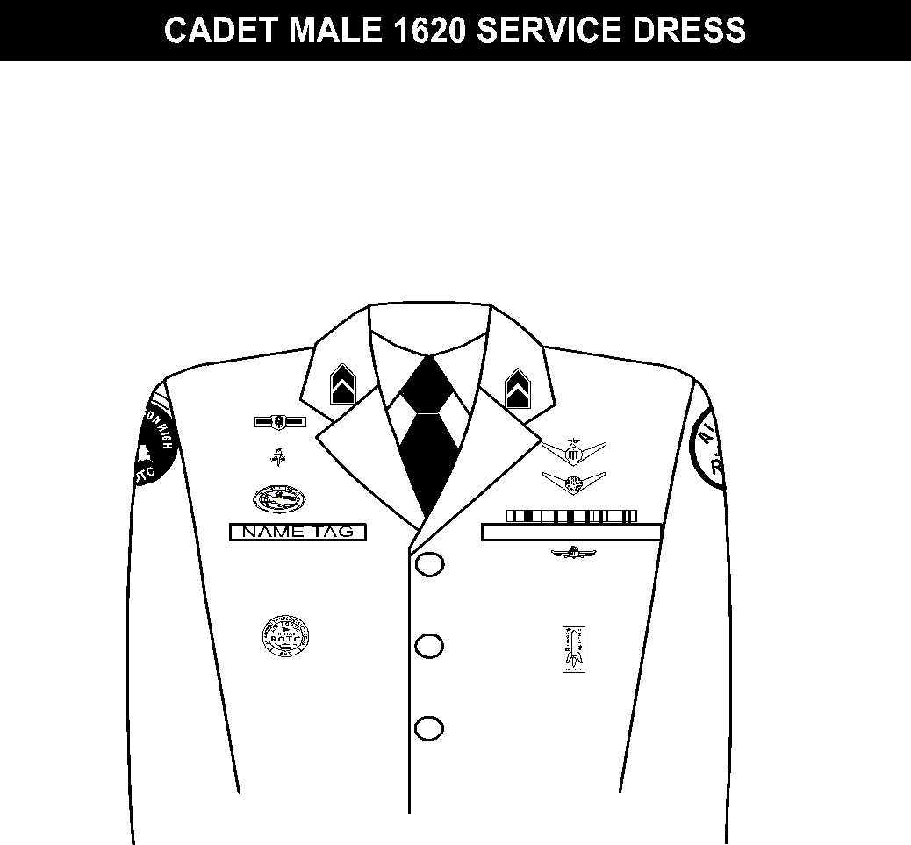
1. (Officers only) When placing rank on epaulet instead of collar, use standard size metal rank, center on epaulet 5/8 in from shoulder seam.
2. Shoulder tabs are centered between unit patch and shoulder seam. If no patch, then 1” below shoulder seam.
3. Unit patch on right sleeve ½ to 1 inch below shoulder seam and centered.
4. Grade insignia (officer/enlisted) is worn on both left and right collar. Airman Basics have no collar insignia.
5. Optional item: center vertically between the shoulder seam and where the underarm side seam joins the armhole sleeve and center horizontally between the center zipper and the sleeve armhole seam.
6. AFJROTC patch on left sleeve ½ to 1 inch below shoulder seam and centered.
7. Jacket will be zipped all the way up or at least halfway.
8. Center insignia horizontally on collar. Place 1 inch from bottom of collar and parallel to the outer edge.
Outer edge
Inner edge
Inner edge
Outer edge
LIGHTWEIGHT BLUE JACKET
COLLAR INSIGNIA
Note 8
Note 7
Note 6
Note 5
Note 3
Note 2
Note 1

Note 4
Note 14
Note 13
Note 12
Note 11
Note 10
Note 9
Note 6
Note 2
Note 3
Note 4

Note 7
Note 5
Rank Placement on Lightweight Jacket

Lightweight Jacket
Service Dress
1. Awareness Presentation Team (APT) badge: Center on welt pocket 3 inches below the top.
2. Name tag: Center between arm seam and lapel with bottom edge parallel to top of welt pocket
3. Kitty Hawk Badge: see note 15.
4. Unit patch: Placed ½ to 1 inch below shoulder seam and centered.
5. Shoulder tabs: Center between unit patch and shoulder seam. If no patch, then 1 inch below shoulder seam.
6. Aerospace Education Foundation (AEF) Badge: see note 15.
7. Distinguished Cadet Badge: see note 15.
8. Grade insignia (officer or enlisted) worn on both lapels. Airman Basics wear lapel no rank insignia. Place insignia halfway up the seam, resting on but not over it. Bottom of insignia is horizontal with the ground.
9. AFJROTC Patch: Placed ½ to 1 inch below shoulder seam, and centered.
10. Flight Solo or Flight Certificate Badge: see note 15.
11. Ground School Badge: see note 15.
12. Ribbons: Center, on but not over edge of pocket. Wear 3 or 4 in a row. Wear all or some.
13. Academy of Model Aeronautic Wings: worn 1 inch below pocket.
14. Model Rocketry Badge: worn 2 inches below AMA Wings or 3 inches below pocket if no AMA Wings are worn.
15. First badge placed ½ inch above name tag or ribbons and is centered horizontally. Additional badges placed ½ inch above previous badge.
Note 8
Note 1
Note: Cadets may wear the rank on both coat and shirt at the same time or only on the coat. The cadets must be in proper uniform at all times. If they have the coat on, the rank insignia must be on the coat. If they remove the coat, the rank must be on the shirt.

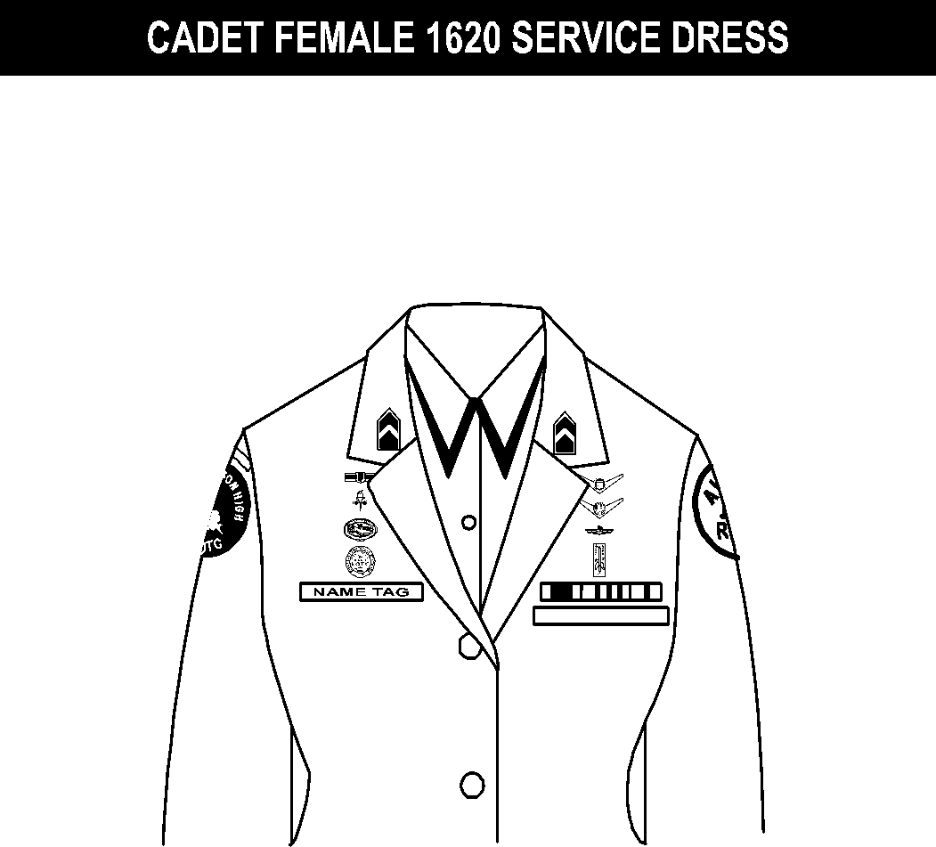
Note 4
Note 3
Note 2
Note 1

Ribbons, Badges, and Rank Placement on Male Service Coat

1. Name tag: authorized for wear and is to be centered on right side, even with to 1 1/2 inches higher or lower than the first exposed button.
2. Awareness Presentation Team Badge: see note 15.
3. Unit patch: center ½ to 1 inch below shoulder seam.
4. Shoulder tab: centered between unit patch and shoulder seam. If no patch, then 1 inch below shoulder seam.
5. Kitty Hawk Badge: see note 15.
6. Aerospace Education Foundation (AEF) Badge: see note 15.
7. Distinguished Cadet Badge: see note 15.
8. Grade insignia (officer or enlisted) worn on both lapels. Airman Basics wear no rank insignia. Place insignia halfway up the seam, resting on but not over it. Bottom of insignia is horizontal with the ground.
9. Flight Solo or Flight Certificate Badge: see note 15.
10. Ground School Badge: see note 15.
11. AFJROTC Patch: center ½ to 1 inch below shoulder seam.
12. Academy of Model Aeronautic (AMA) Wings: see note 15.
13. Model Rocketry Badge: see note 15.
14. Ribbons: center ribbons resting on but not over edge of welt pocket. Wear 3 or 4 in a row. Wear all or some.
15. First badge placed ½ inch above name tag or ribbons (whichever is appropriate) and is centered horizontally. Additional badges placed ½ inch above previous badge.

Ribbons, Badges, and Rank Placement on Female Service Coat
Note: Cadets may wear the rank on both coat and shirt at the same time or only on the coat. The cadets must be in proper uniform at all times. If they have the coat on, the rank insignia must be on the coat. If they remove the coat, the rank must be on the shirt.

Note 8
Note: Cadets may wear the rank on both coat and shirt at the same time or only on the coat. The cadets must be in proper uniform at all times. If they have the coat on, the rank insignia must be on the coat. If they remove the coat, the rank must be on the shirt.

Note 9
Note 10
Note 11
Note 12
Note 13
Note 14
Note 7
Note 6
Note 5
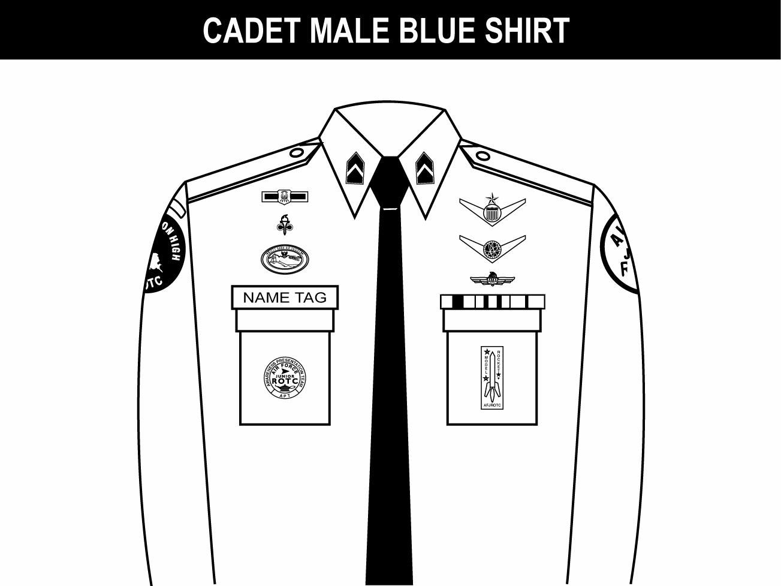
1. Awareness Presentation Team (APT) and Model Rocketry Badge are centered on the pockets on the appropriate sides as displayed above.
2. Name tag: authorized for wear and is to be grounded and centered over wearer’s right pocket.
3. Unit patch: center ½ to 1 inch below shoulder seam.
4. Shoulder tab: center between unit patch and shoulder seam. If no patch, then place 1 inch below shoulder seam.
5. Kitty Hawk Badge: see note 15.
6. Aerospace Education Foundation (AEF) Badge: see note 15.
7. Distinguished Cadet Badge: see note 15.
8. Grade insignia (officer or enlisted) worn on both left and right collar, centered side to side and top to bottom. Enlisted rank’s bottom point of torch points toward the point of the collar. Officer top point of rank aligned with point of collar. Airman Basics have no insignia.
9. (Officers only) When using officer cloth rank on epaulets versus miniature metal rank on collar, place as close as possible to shoulder seam.
10. Flight Solo or Flight Certificate Badge: see note 15.
11. Ground School Badge: see note 15.
12. Academy of Model Aeronautic (AMA) Wings: see note 15.
13. AFJROTC Patch: center ½ to 1 inch below shoulder seam.
14. Ribbons: ground and center on pocket.
15. First badge placed ½ inch above name tag or ribbons and is centered horizontally. Additional badges placed ½ inch above previous badge.
Note 1
Note 14
Note 13
Note 10
Note 12
Note 11
Note 9
Note 8
Note 7
Note 6
Note 5
Note 4
Note 3
Note 2
Blue Shirt

Ribbons, Badges, and Name Tags on Male Shirt

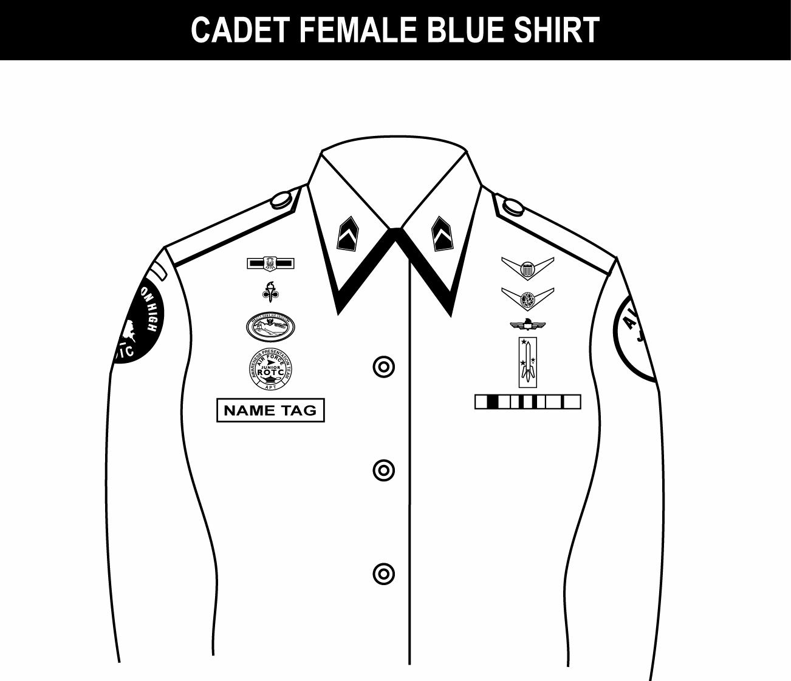
1. Name tag: authorized for wear and is to be centered on right side, even with to 1 1/2 inches higher or lower than the first exposed button.
2. Awareness Presentation Team Badge: see note 16.
3. Unit patch: center ½ to 1 inch below shoulder seam.
4. Shoulder tab: centered between unit patch and shoulder seam. If no patch, then 1 inch below shoulder seam.
5. Kitty Hawk Badge: see note 16.
6. Aerospace Education Foundation (AEF) Badge: see note 16.
7. Distinguished Cadet Badge: see note 16.
8. Grade insignia (officer or enlisted) worn on both left and right collar, centered side to side and top to bottom. Enlisted rank’s bottom point of torch points toward the point of the collar. Officer top point of rank aligned with point of collar. Airman Basics have no insignia.
9. (Officers only) When using officer cloth rank on epaulets versus miniature metal rank on collar, place as close as possible to shoulder seam.
10. Flight Solo or Flight Certificate Badge: see note 16.
11. Ground School Badge: see note 16.
12. Academy of Model Aeronautic (AMA) Wings: see note 16.
13. AFJROTC Patch: center ½ to 1 inch below shoulder seam.
14. Model Rocketry Badge: see note 16.
15. Ribbons: Center, parallel with ground. Align with bottom of name tag. Or, if no name tag, align bottom of ribbons even with to 1 ½ inches higher or lower than the first exposed button.
16. First badge placed ½ inch above name tag or ribbons (whichever is appropriate) and is centered horizontally. Additional badges placed ½ inch above previous badge.
Note 7
Note 6
Note 5
Note 4
Note 3
Note 2
Note 1
Note 8
Note 9
Note 10
Note 11
Note 12
Note 13
Note 14
Note 15

Ribbons, Badges, and Name Tags on Female Shirt

Airman Battle Uniform (ABU)
- WEAR: Airman Battle Uniform (ABU) is authorized for AS II/III/IV cadets only. ABUs will only be worn when directed by the SASI. At all other times, cadets will wear the Blue Shirt or the Service Dress uniform. ABU must be worn in accordance with this Guide and all other applicable directives.
- CARE: ABUs must be neat and clean at all times.
- BLOUSE & TROUSERS: The blouse will not be tucked into the trousers. If worn rolled up, the sleeve material will touch or come within one (1) inch of forearms when arm is bent at a 90-degree angle. The trousers will be worn on the hips and bloused using the blousing elastic or tucked into the top of the boot.
- BELT & BUCKLE: The desert belt and buckle will be worn with the trousers.
- UNDERGARMENTS: Undershorts and a crew neck, desert sand T-shirt must be worn at all times. The long-sleeve mock turtle neck t-shirt is authorized during cold weather.
- FOOTWEAR: Sage green combat boots will be worn with green boot socks. Athletic shoes may be authorized by the SASI for specific events.
- HEADGEAR: ABU Cap or Beret: Worn squarely on the head with no hair protruding in front of the cap. AFJROTC hat insignia will be worn centered on the front of the hat. Cadets may stow the hat in either of the lower cargo pockets on the ABU trousers when not wearing.
- COLD WEATHER: Cadets may purchase the ABU Jacket or fleece outer garment for wear during the winter. As an alternative, cadets may wear long underwear under the ABU as long as only the desert sand T-shirt is showing (i.e.- must wear the blouse as long sleeves).
- GLOVES/MITTENS/WATCH CAP: Black or sage; Gloves: leather, knitted, tricot, or suede (or a combination of these) gloves or mittens may be worn with the uniform. Fleece or knit cap.

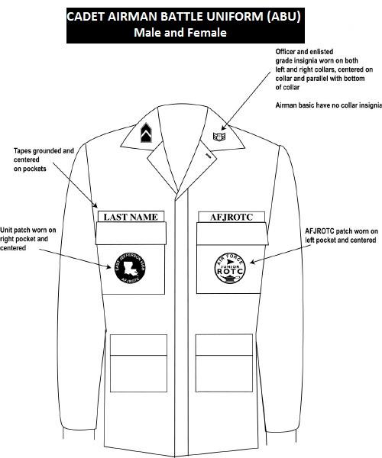

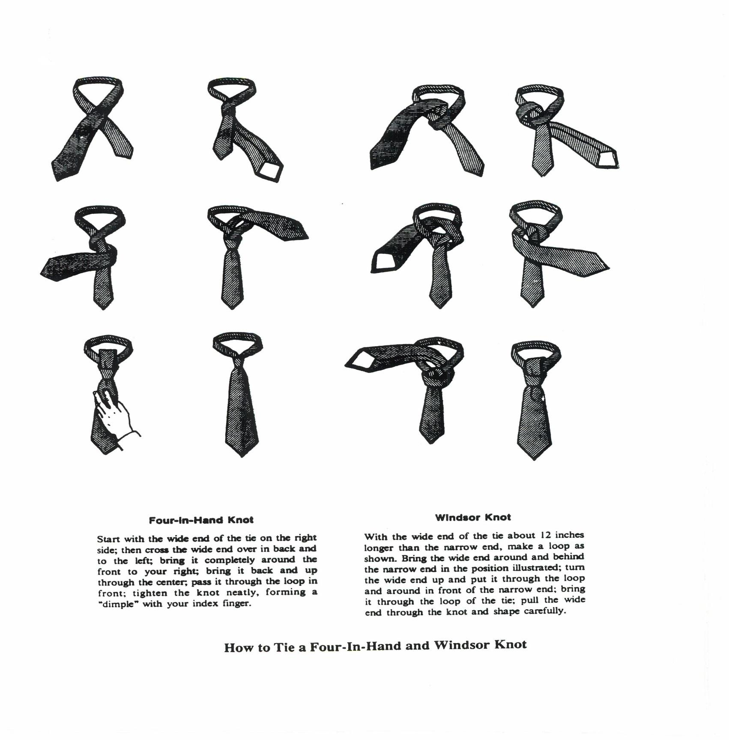
Tying A Tie

CHAPTER 8: SALUTING RULES
    - The salute, in its various forms, is a courteous exchange or greeting and is considered a military greeting the world over. In many countries, as in our country, it is a symbol of respect. American military personnel consider the salute as a courteous and respectful greeting between members of an honorable profession. It is one of the oldest traditions binding military professionals together.
    - You will be taught the proper manner of saluting and the rules governing its use among military services. A salute is required when a cadet is outside in uniform and encounters any active duty or retired officer or a cadet officer of higher rank, who is also in uniform.
    - The salute is rendered indoors only when cadets are in formations, participating in ceremonies, reporting to cadet officers, or reporting to the SASI/ASI. The proper sequence of reporting includes the rendering of the salute and the statement “Sir/Ma'am, Cadet (last name) reporting as ordered,” or other appropriate comment. The cadet holds the salute until it is returned or otherwise acknowledged by the officer. When the purpose of the report or meeting is completed, the cadet again salutes; the officer will return the salute or otherwise acknowledge it and the cadet will turn sharply to the most direct exit and leave.
    - A salute is never given or returned while running. The cadet will come to quick time (to a walk) and render the salute when approximately three paces from the officer.
    - Cadets not in uniform may salute as if they were in uniform.
    - A cadet of junior grade will salute a cadet officer of higher grade first and hold the salute until it is properly returned or otherwise acknowledged.
    - If a cadet is in uniform and the American Flag is being raised or lowered from any flagstaff, he or she will assume the position of attention facing the flag, render the salute, and hold it until the flag has reached the summit or base of the flag staff. If the cadet is in civilian clothes, he or she will assume the position of attention facing the flag and place the right hand over the heart. If a male cadet wearing civilian attire is also wearing headgear, he will remove it and hold the headgear to his left shoulder so that the right hand is over the heart.
    - When outdoors, cadets in uniform at Dr. Phillips High School will render the salute during flag raising ceremonies and public reciting of the Pledge of Allegiance.
    - If the cadet is outdoors and the National Anthem or “To The Colors” is being played, the cadet in uniform shall stand at attention, face the flag or music, and render the salute until the music or call ends.
    - When a cadet is late for formation, he or she will approach the cadet or person in charge when the formation is at halt, salute, and request permission to fall-in.
    - Cadet Officers and Cadet NCOs will correct observed saluting violations in a courteous and helpful manner. All cadets are expected to accept these corrections as being constructive in nature. Repeated violations of the saluting requirements will result in discrepancy action using the AFJROTC FL-881 Form 341.
    - Cadets will also salute all Commissioned Officers, Warrant Officers, officers of foreign allied nations, and the President of the United States.

CHAPTER 9: CO-CURRICULAR ACTIVITIES
Co-curricular activities are an important part of the AFJROTC and high school experience. They are an excellent tool for learning self-discipline, leadership, cooperation, and self-confidence. They can be very enjoyable, and give you a strong sense of belonging; our unit has a number of these activities available to you. Meeting times will be scheduled at the beginning of each school year.
1. HONOR GUARD - The Honor Guard is open to all AFJROTC cadets and represents DPHS at ceremonial functions. It presents the colors at home football games and a variety of ceremonial activities both on campus and throughout the community. The Honor Guard will practice a minimum of one day per week after school.
a. Goals and Objectives:
  - To be precise in color guard procedures.
  - To be excellent representatives of DPHS and present our national and state flags with distinction and honor throughout the community.
  - To become better leaders.
b. To qualify for Honor Guard a cadet must:
  - Attend all practices, unless excused by an Instructor or Honor Guard Commander/Deputy.
  - Respond positively to the leadership of the Commander/Deputy.
  - Become proficient at all routines.
  - Cooperate with team members.
  - Maintain an excellent uniform appearance at all times.
  - Attend ALL performances/activities cadets agree to attend.

****SPECIAL NOTE****
It is the responsibility of Honor Guard members to find a replacement and then notify their individual Commander of that replacement (with contact phone number) when they cannot attend events. Do not disrespect the team, the occasion, the event, or the flag.

2. KITTY HAWK AIR SOCIETY (KHAS) is the National Honor Society of Air Force JROTC cadets who subscribe to and actively promote high levels of academic achievement, service to school and community, patriotism and good citizenship, and support airpower in its role in national security. The Kitty Hawk Air Society is affiliated with the Air Force Association and supports its effort to further aerospace education. The Dr. Phillips High School, 'Wright Flight' Chapter, was activated and received its charter on 19 September 1989.
a. Kitty Hawk Air Society meetings will be one day per week after school.
b. Goals and Objectives:
  - Promote high academic achievement.
  - Support school and community.
  - Promote self-confidence and initiative.
  - Promote patriotism and a high degree of personal honor.
  - Promote aerospace power in the defense of the nation.
  - Meet and maintain a minimum scholastic level to retain membership.
c. Applicants for membership must:
  - Be of good standing within our school and community.
  - Have a minimum cumulative GPA of 2.75 (weighted).
  - Have a minimum Air Force JROTC grade of “B”.
  - No failing grade in any class.
d. Cadet members of the society shall receive the KHAS badge at the end of the school year if they volunteer at least half of the number of hours available and maintain the grade requirements above.
e. Any cadet in probationary status, or who allows their membership in the society to lapse, will not be allowed to wear the KHAS badge on their uniform.
3. AWARENESS PRESENTATION TEAM (APT): APT is a highly specialized group of cadets primarily designed to provide positive role models for elementary and middle school students. The cadets may also give presentations to other groups, such as the Boy/Girl Scouts, etc. This involves teaching them about American history, integrity, peer-pressure, alcohol and drug awareness, goals, and much more. This team is designed to have cadets who are an example for others to follow and be role models for younger students. To serve on this prestigious team, cadets will be nominated by the APT Commander and approved by the SASI or ASI.
- APT meetings will be one day per week after school.
- Requirements for APT:
- Above 85% dress and appearance grade
- No lower than 2.5 GPA
- Display leadership
- Display public speaking skills
- No disciplinary actions
- Be responsible for all work missed while not at school

4. SOCIAL ACTIVITIES - The cadet corps conducts a variety of social events, which may include Military Ball, Picnic, and Field Days. These events are planned by the cadet staff and are open to all members of the cadet corps.

5. RECRUITING - The primary way that FL-881 continues its existence! Recruiting is mainly conducted through recruiting visits to middle schools, orientations, club fairs, and cadets recruiting other students one-on-one. Recruiting visits are conducted by a recruiting team made up of three to six cadets and the ASI or SASI. Cadets participating in recruiting visits to schools will be awarded a Recruiting Ribbon at the end of the school year.
One-on-one recruiting is the most powerful way to keep FL-881's enrollment healthy. Every cadet should consider himself or herself to be a recruiter. Asking a friend to join should be easy if you believe in the AFJROTC program. Each cadet who gets a student to enroll in FL-881 earns a Recruiting ribbon (with confirmed registration).

6. FLAG DISPOSAL (according to VFW Resolution 206, 8/00) Ceremony may be conducted privately or publicly. VFW suggests the following procedures be used in private or public to dispose of a torn, soiled or badly faded U.S. flag:
- Fold flag in customary manner
- Place flag on substantial fire
- Require individuals to stand at attention, salute flag
- Recite Pledge of Allegiance and have moment of silent reflection
- Extinguish fire and bury ashes after flag is consumed
Conform to local/state fire codes or ordinances

CHAPTER 10: AWARDS AND DECORATIONS

A number of distinctive awards are authorized for AFJROTC cadets to recognize outstanding academic, leadership, and citizenship performance. Medals, ribbons, and certificates are awarded in the following categories:

National Awards: National awards are awarded by national veterans, military, and patriotic organizations. These awards are presented at our annual awards ceremony. The Awards are described in the Uniform And Awards Guide published by Headquarters Air Force JROTC.
Air Force JROTC Sponsored Awards: The following awards (not all-inclusive) are also authorized by the Uniform and Awards Guide.
Outstanding Cadet Ribbon - Awarded annually to the outstanding first-year, second-year, third-year, and fourth-year cadet. The recipient from each class must be of high moral character, demonstrate positive personal attributes, display outstanding military potential, and attain academic and military excellence.
Leadership Ribbon - Awarded for outstanding performance in a position of leadership as an AFJROTC cadet in corps training activities. Limited to 5 percent of the eligible group to ensure recognition of cadets who have consistently displayed outstanding leadership ability above and beyond expected performance.
Achievement Ribbon - Awarded for a significant achievement. Limited to 5 percent of the cadet corps. Individuals may not receive more than one ribbon during a 1-year period.
Superior Performance Ribbon - Awarded annually for outstanding achievement or meritorious service rendered specifically on behalf of AFJROTC. Presented for a single or sustained performance of a superior nature. Limited this ribbon to 10 percent of the cadet corps to ensure recognition of achievements and services which are clearly outstanding and exceptional when compared to achievements and accomplishments of other cadets.
Distinguished Unit Award (DUA) - Awarded to cadets enrolled during the academic year when a unit is selected by HQ AFJROTC to receive the DUA. Units have to set and accomplish goals for the year to attain this award.
Top Performer Award - The Cadet Top Performer Award is a Headquarters, AFJROTC award presented to a maximum of 2% of the current unit cadet corps population. The award will recognize a cadet’s performance in the following key areas: Leadership and job performance: in primary duty and specifically in preparation for the unit’s annual assessment. Leadership qualities: involvement and positions held in extracurricular activities. Academic performance: nominee must be in good academic standing in all high school course work. Significant self-improvement. Community involvement. Other accomplishments.
Academic Ribbon - Awarded for academic excellence as signified by attaining an overall grade point average of at least “B” for one academic term, in addition to an “A” average in AFJROTC.
Outstanding Flight Ribbon - Awarded each academic term to members of the outstanding flight under criteria determined by instructors (more information included later in this chapter).
Leadership School Ribbon - Awarded for completion of an approved leadership school program of at least 5 days duration. Add a silver star for outstanding performance or leadership ability at a Leadership School. The star is limited to 10 percent of the class.
Drill Competition Ribbon - Awarded to drill team members for placing first, second or third place in an Air Force or Joint Service drill meet.
Co-curricular Activities Leadership Ribbon - Awarded for leadership in AFJROTC cocurricular activities (such as dining-in chairperson, military ball chairperson, etc.). The recipient must have demonstrated exceptional leadership in achieving objectives through the coordinated efforts of others. This award may be earned a maximum of four times. An oak leaf cluster should be added to this ribbon for each additional award.
Drill Team Ribbon - Awarded for distinguished participation in at least 75 percent of all drill team events per academic year, or 10 drill team events in an academic year, whichever is lower. An oak leaf cluster should be added to this ribbon for each year of qualifying membership beginning with the second year.
Color Guard Ribbon - Awarded for distinguished participation in at least 75 percent of all color guard events per academic year, or 10 color guard events in an academic year, whichever is lower. An oak leaf cluster should be added to this ribbon for each year of qualifying membership beginning with the second year.
Service Ribbon - Awarded for distinctive performance in school, community, or AFJROTC service projects. Limit to members whose active participation in a service project contributed significantly to the goals of the organization.
Recruiting Ribbon - Awarded for outstanding effort in support of unit recruiting activities.
Activities Ribbon - Awarded for participation in co-curricular activities other than Drill, Color Guard, and Saber teams. These include, but are not limited to orienteering teams, model rocketry clubs, AFJROTC academic teams, and AFJROTC sports teams. An oak leaf cluster should be added to this ribbon for each year of membership beginning with the second year.
Attendance Ribbon - Awarded to cadets with no more than 4 excused absences and no unexcused absences in an academic term.
Good Conduct Ribbon - Awarded to cadets with no suspensions of any kind, no adverse reports from other staff or faculty in an academic term
Dress and Appearance Ribbon - Awarded for wearing uniform on all designated uniform days and conforming to all AFJROTC dress and appearance standards
Longevity Ribbon - Awarded for successful completion (grade of 2.0 or above) of each AS year.
Badges and Headgear:
Service Caps - As an optional wear item, the service cap and JROTC insignia shall be purchased by individual cadets at no expense to the unit.
Berets - A rite of passage for AS IV cadets. As an optional wear item, the beret shall be purchased by individual cadets at no expense to the unit. The appropriate JROTC officer or enlisted insignia shall be worn.
Awareness Presentation Team Badge - Awarded for participation on Awareness Presentation Team.
Kitty Hawk Air Society Badge - Awarded to cadets who are members of the Kitty Hawk Air Society.
Aerospace Education Foundation (AEF) Academic Cadet Badge - Awarded to rising Junior and Senior cadets for academic excellence as signified by attaining an overall 3.3 grade point average with no grade below “C” on their transcript.
Distinguished AFJROTC Cadet Badge - The award recognizes one outstanding 3rd-year cadet. The recipient wears the award their final year in the AFJROTC program. The recipient must be of high moral character, demonstrate positive personal attributes, display outstanding military potential, and maintain consistent academic and military excellence.
- Leadership Ribbon
- Achievement Ribbon
- Superior Performance Ribbon
- Academic Ribbon
- Co-curricular Activities Leadership Ribbon
- Service Ribbon
Local Recognition:
Honor Squadron Award - Recognizes the outstanding squadron that excels in AFJROTC academics, uniform wear and personal appearance, fundraising, and drill competition. The overall academic, uniform wear, fundraising, and personal appearance score will be the average for all squadron members. All competition categories will be weighted in order of importance. The drill sequence for the drill competition will be given to each squadron commander early in the semester and practice times will be set aside during the semester. The SASI and ASI will select the honor squadron prior to the annual awards ceremony. Squadron members will be awarded the outstanding flight ribbon and their flight guidon will be posted in the classroom.
Cadet of the Month - This award program promotes excellence and teamwork within the squadron during each academic month. Each Squadron Commander will identify to the designated staff member their outstanding cadet in a one page written recommendation by the suspense date established. The Cadet Group Commander, SASI, and ASI will review recommendations and designate the outstanding cadets in the Corps.
The award is based on the "whole person" concept to include academic excellence, teamwork, cooperation with flight commander and instructors, uniform wear and personal appearance excellence, school, community, and corps involvement; and conduct.
Graduation Cords - Graduating cadets may receive the graduation cord if they meet the following criteria:
- A cumulative 3.0 GPA or better
- A cumulative 3.5 GPA for their AFJROTC years (minimum of 3)
- No school disciplinary actions such as suspensions (in or out of school), detentions, etc.
- Instructors must agree the cadet has shown honor while serving in AFJROTC and followed the Air Force Core Values.

CHAPTER 11: ACTIVITIES AND FIELD TRIPS

1. Air Force JROTC cadets will participate in a number of school approved field trips and activities. Many of these activities will be after school hours, but several will occur during the normal school day.

2. The following activities may take place both during school and outside school hours.

Color Guard Performances - Most will be outside school hours. This activity provides a valuable community patriotic service. Cadets gain valuable leadership experience, self-assurance, patriotism, and increased appreciation for individual reliability and punctuality.

Community Patriotic Ceremonies - We often receive requests to provide cadet participation beyond a Color Guard in a community ceremony. Cadets present an impressive image of the Dr. Phillips High School student, and learn about patriotism and service to community.

Orientation Flights - We may have the opportunity to arrange orientation flights. This presents the cadets a valuable opportunity to experience flight first-hand.

Community Service Activities - These are almost all outside school hours. Cadets experience leadership, value of service to community, improved self-image, and provide an excellent example of the Dr. Phillips student to community leaders.

Squadron Picnic - The picnic will be after school. Cadets have the opportunity to practice their leadership and management skills. The picnic helps improve cadet corps unity and esprit de corps.

Drill Meets - These are mostly outside school hours. Allow cadets to practice and display their leadership and precision drill skills through competition with other Florida schools. Promotes unity and esprit de corps.

Fundraising - FL-881, besides being a class, is also a “club,” therefore we need money to support activities and projects that the Air Force and DPHS do not fund. Normally, two major fund-raising activities will be scheduled during the school year. Types of activities for which funds will be used are:

Military Ball, Dining Out, Awards Banquet/Brunch, etc.
Field Day, Drill Meets, Picnics, etc.
Some Honor Guard Team equipment.
Some field trip costs not covered by AF funding.
Other items as agreed on.

3. These activities will normally take place during school hours.

Memorial Formations – In honor of significant events in our country (9-11, Pearl Harbor Day, etc.), the Cadet Corps normally performs a formal formation flag-raising ceremony. All cadets are expected to attend. All of the staff and students are invited, as well as local veteran’s groups, police officers and firefighters.
Middle School Visits - Normally, 6-8 cadets will visit each feeder middle school once each semester as a recruiting visit through the PE classes. We also support the guidance office during the 8th grade orientation and registration process to present a message on the positive benefits of AFJROTC to the incoming 9th grade students.

Elementary School - We occasionally receive requests to bring cadets and assist with events, such as a field day, at an elementary school. This activity provides a positive example of high school students to elementary students, gives the cadets leadership training, and contributes to the cadet’s positive self-image.

Field Day - Field Day provides the cadet staff an excellent opportunity to develop their leadership and management skills. Field Day makes a vital and outstanding contribution to cadet corps unity and esprit’ de corps.

IMPORTANT NOTE: Students who have a cumulative GPA of less than a 2.0 generally may not participate in activities during school other than during their assigned class period.

4. We participate in a number of Field Trips, locations may include:

Kennedy Space Center - Aerospace Science III is based on the study of rockets and space travel. A tour of the Kennedy Space Center and a visit to the education center is an excellent tool for first-hand knowledge of space travel and the science involved.

Military Heritage Museum - Aerospace Science I discusses the history of aviation. This is an excellent opportunity for the cadets to view many of the aircraft they study in class.

Air Warfare Symposium - We are very fortunate this annual event is conducted here in Central Florida. We are invited to view the aerospace manufacturers' exhibits. This is an excellent opportunity for our cadets to see firsthand what is going on in the world of aerospace.

Air Force Base Visits - Visits to Air Force Bases give the cadets a good look at the various jobs that are performed in the Air Force. Also, these visits give the cadet a greater appreciation how much effort is involved in providing for the defense and security of our nation.

5. We conduct an annual Cadet Leadership Course (CLC). CLC is normally conducted at either MacDill AFB or Patrick AFB, but can be elsewhere. The cadets selected to participate in this week long military experience live in military quarters, have their meals in the dining hall, and are exposed to a large number of Air Force functions and activities. This experience provides cadets a total separation from home life and an opportunity to meet new challenges and develop leadership skills.

CHAPTER 12: WING CHAIN OF COMMAND
The positions listed below are filled at the discretion of the SASI and the needs of the cadet corps. Responsibilities for each position can be found in the Cadet Staff Guide, which is available online at our DPHS JROTC website, or ask a Flight Chief or Squadron Commander.
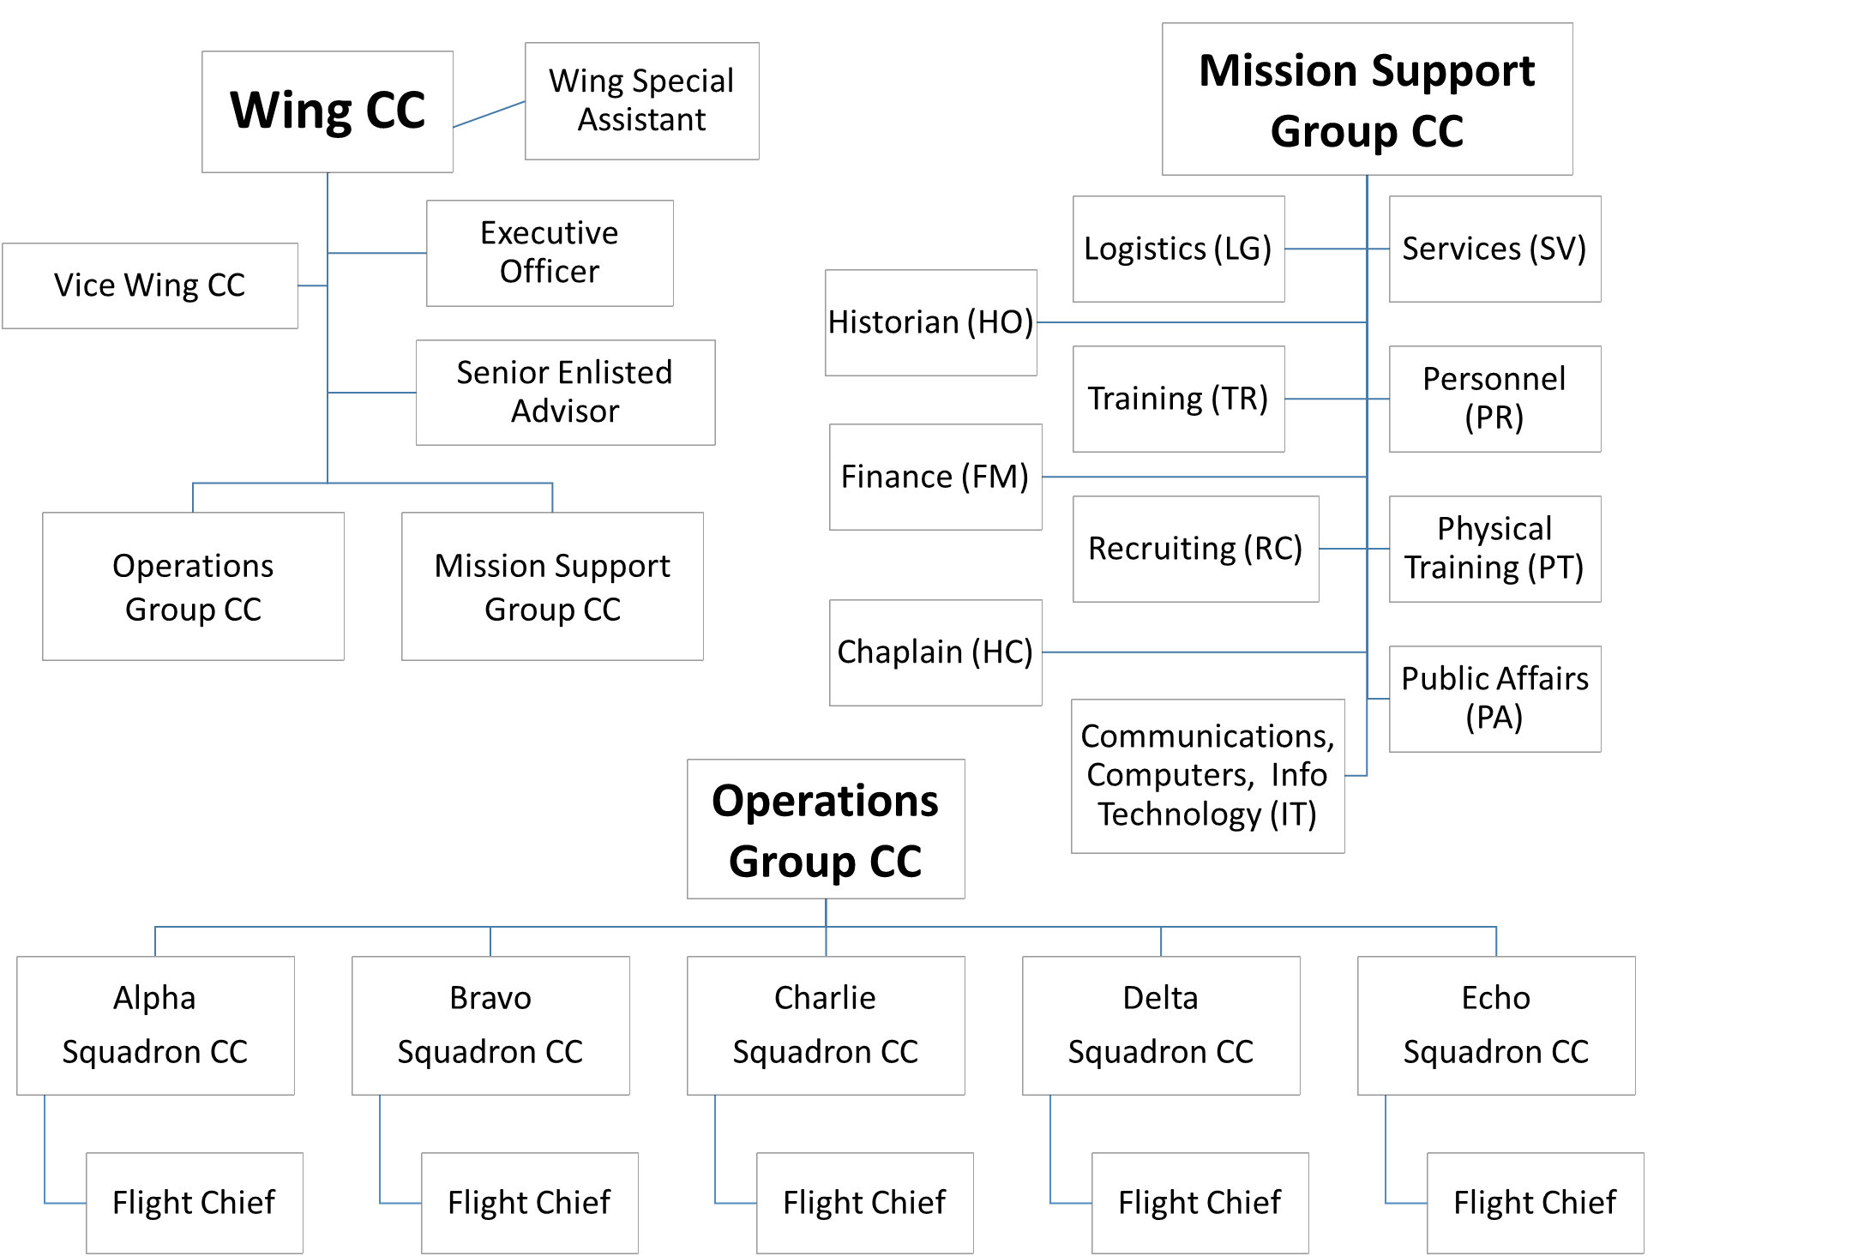

CHAPTER 13: CADET PROMOTION SYSTEM
1. Cadet Rank/Grade. Cadet “rank” and cadet "grade" are interchangeable -- they basically mean the same thing. It is the level of promotion a cadet has achieved.
2. Permanent Rank. All cadets in their first year of JROTC enter as an Airman Basic (no stripes). At the end of the first and third marking periods, all eligible cadets will be evaluated for promotion using a Performance Report (see Staff Guide for more details). If promoted, each cadet’s permanent rank will increase one “grade” (one stripe). For example, if you get promoted both times your first year, you will enter your second year as an Airman First Class (2 stripes).
3. Temporary Rank: Those on the Wing Staff hold temporary positions, thus, they have temporary rank. When someone is no longer on Wing Staff, he/she will go back to his/her permanent rank. If he/she changes jobs on Wing Staff, he/she will only where the rank of the current Wing Staff position.
4. Step Promotions. A cadet may be appointed to a higher rank on the spot without having to test for it for superior performance as deemed appropriate by the SASI. Step promotions occur on very rare occasions and only when it is in the best interest of the corps.
5. Promotion Policy. Promotions go to those who have earned it. Cadets must be eligible for promotion in order to be promoted. The intent of the promotion system is to reinforce the Dr. Phillips High School Air Force JROTC program and its ideals (mission statement, honor code, core values, etc.).
6. Promotion Eligibility. All cadets in the rank of airman, or above, are test-eligible with the following exceptions: those who are on Dr. Phillips High School Suspension (in or out of school suspension), Academic Probation or probation within the corps.
- Cadet Enlisted Promotions. In order to be eligible for promotion students must maintain a 2.0 or better in leadership and academics in AFJROTC, and a cumulative GPA of 2.0 or better. Promotion is at the discretion of the Wing Commander and the SASI/ASIs.
- Cadet Officer Promotions. In order to be eligible for promotion students must maintain a 2.5 or better in leadership and academics in AFJROTC, and a cumulative GPA of 2.0 or better. Promotion is at the discretion of the Wing Commander and the SASI/ASIs.
7. Promotion Process (for other than Step Promotions).
- The Cadet Review Board performs a records review to determine eligibility for promotion.
- A Cadet Performance Report must be accomplished, with a recommendation for promotion.
- The cadet passes the appropriate promotion test.
- Promotion results will be posted on the Cadet Bulletin Board after they are announced in each squadron.
8. Promotion Knowledge Test (PKT). Cadets are expected to know the Cadet Guide very well, especially the AFJROTC mission and objectives, the honor code, the Air Force Core Values, JROTC procedures, proper wear of the uniform, names and ranks of the Wing Staff (the chain of command), customs and courtesies, saluting rules and the “knowledge” information. Appropriate drill questions will also be included.
The sources for promotion test questions are: Cadet Guide, appropriate Leadership Education information, AFMAN 36-2203, pertinent HQAFJROTC directives or policy letters, and any other FL-881 guidance.

ATTACHMENTS

ATTACHMENT 1: OPEN RANKS INSPECTION

1. FLIGHT, FALL-IN -- (Size the flight):
A). RIGHT, FACE
If you are taller than the person in front of you, tap them on the shoulder and move forward.

B). RIGHT, FACE
If you are taller than the person in front of you, tap them on the shoulder and move forward.

2. ABOUT, FACE

3. OPEN RANKS, MARCH

4. READY, FRONT

5. COUNT, OFF
A). All eyes except for element leaders turn to right on preparatory command COUNT, at command of execution OFF, eyes snap forward and cadets shout position number.
B). Check alignment of each element

6. REPORT: Flight Chief will
A). Salute
B). Sir, ___ Flight ready for inspection.

7. INSPECTION: Flight Chief conducts uniform inspection on each cadet.

8. SECOND and THIRD ELEMENTS, PARADE REST, as required.

9. CLOSE RANKS, MARCH when complete.

ATTACHMENT 2: DRILL TERMS
The following list contains the most frequently used drill terms and a definition of each. All cadets are required to know and be able to explain these drill terms.
  - Base Element -- element on which a movement is planned, regulated, or aligned. Element farthest to the right when in column formation or at the rear of the formation when in line formation.
  - Cadence -- uniform step and rhythm in marching - the number of steps marched per minute.
  - Cover – alignment of one element member directly behind the element member in front of them while maintaining proper distance.
  - Distance -- prescribed space from the front of one element member to the rear of the element member directly in front of them. The distance between individuals in formation is 40 inches as measured from their chests to the backs of the persons directly in front of them.
  - Double time -- rate of marching 180 steps (30 inches in length) per minute.
  - Dress -- alignment of flight members to the individuals on their immediate right or left.
  - Element -- basic formation; the smallest drill unit comprised of at least 3 cadets, one of whom is designated the element leader.
  - File -- single column of persons placed one behind the other.
  - Flank -- extreme right or left (troops' right or left) side of a formation in line or in column.
  - Flight -- at least two, but not more than four elements.
  - Formation -- arrangement of the units in any prescribed manner.
  - In Column -- arrangement of elements side by side with element leaders at the order of the formation.
  - Inverted Column -- arrangement of elements side by side with element leaders to rear of the formation.
  - In Line -- arrangement of elements one behind the other with the element leaders to the extreme right flank.
  - Interval -- space between individuals placed side by side. Normal interval is an arm’s length.
  - Inverted Line -- arrangement of elements one behind the other with the element leaders to the extreme left flank.
  - Mark Time -- marching in place at the rate of 100 to 120 steps per minute.
  - Pace -- step of 24 inches. This is the length of a full step in quick time.
  - Quick Time -- rate of marching at 100 to 120 steps (24, or 12 inches in length) per minute.
  - Step -- prescribed distance measured from heel to heel between the feet of a marching person.
  - Half-step -- pace of 12 inches.
  - Preparatory Command -- drill command which prepares you for the movement to be executed.
  - Command of Execution -- drill command which tells you when to execute the drill movement.
  - Detail -- formation of cadets to serve a specific purpose.
  - Squadron -- unit consisting of two to four flights.

ATTACHMENT 3: DRILL COMMAND SEQUENCES
30 Commands

Student’s name: __________________________ Squadron: ________ Date:______________

Evaluator: _________________________________________________________________

1. Fall-in ____ | 19. To the rear _____
2. Right face (2X) for sizing ____ | 20. Column right_____
3. Open ranks ___ | 21. Forward ____
4. Ready Front (Include count off and inspection) ___ | 22. Eyes right ____
5. Close ranks ___ | 23. Ready front ____
6. Present arms ___ | 24. Column right ____
7. Report into drill area ____ | 25. Forward ____
8. Order arms ____ | 26. Change step ____
9. Parade Rest ____ | 27. Column right ____
10. Tenhut ___ | 28. Forward ____
11. Left face ____ | 29. Flight halt ____
12. About face ____ | 30. Left face____
13. Forward ____ | 31. Right step ___
14. Right flank ____ | 32. Flight halt ___
15. Left flank ____ | 33. Report out ___
16. Column Right ___ | 34. Dismissed ___
17. Forward ____ | Bearing: Exc___ Good ___ Fair___ Poor___
18. To the rear _____ | Correctly called commands Yes ___ No____
 | Called cmds on correct foot Yes ___ No___

Report In: Cadet _____ requests permission to use the Drill Area, Sir/Ma’am. Then perform an about face and face your flight.

Report Out: Cadet _____ has completed regulation drill and requests permission to leave the Drill Area, Sir/Ma’am. Then perform an about face and face your flight: “Dismissed.”

54 Commands
Student’s name: ________________________ Squadron: __________ Date:______________
Evaluator _____________________________
1. Fall-in ____ | 39. Right flank ____
2. Right face (2X) for sizing ____ | 40. Column Right ___
3. Open ranks ___ | 41. Forward ____
4. Ready Front (conduct inspection) | 42. Eyes right ____
5. Close ranks ___ | 43. Ready front ____
6. Right face ____ | 44. Column right ____
7. Forward ____ | 45. Forward ____
8. Halt_____ | 46. Double Time _____
9. Left Face | 47. Quick Time _______
10. Present arms ___ | 48. Halt (5 seconds) _____
11. Report into drill area ____ | 49. Forward ____
12. Order arms ____ | 50. To the rear____
13. Open Ranks _____ | 51. Halt ____
14. Ready front _____ | 52. About face_____
15. Close ranks ____ | 53. Column of Files from the Right…___
16. Parade Rest ____ | 54. Halt (5 seconds) ____
17. Tenhut ____ | 55. Reform columns of ____ to the left
18. Count off _____ | 56. Forward ____
19. Left face ____ | 57. Left Flank _____
20. About face ____ | 58. Flight halt ____
21. Close ______ | 59. Present Arms_______
22. Extend _____ | 60. Report Out_____
23. Left face ___ | 61. Order Arms___
24. Left step_____ | 62. Right Face____
25. Halt (5 seconds)_____ | 63. Forward____
26. Right face _____ | 64. Halt____
27. Mark time_____ | 65. Dismissed___
28. Forward_____
29. Change step_____
30. Column right ___
31. Forward_____
32. Counter____
33. Forward ____ | Bearing: Exc___ Good ___ Fair___ Poor___
34. Column Half Left____
35. Column Half Left_____ | Correctly called commands Yes ___ No____
36. Column Left______
37. Forward_____ | Called cmds on correct foot Yes ___ No___
38. Left flank ____
Report In: Sir/Ma’am, Cadet/Rank Doe from Dr. Phillips HS reporting in for regulation drill.
Report Out: Sir/Ma’am Cadet/Rank Doe from Dr. Phillips HS has completed regulation drill and requests permission to leave the Drill Area.

ATTACHMENT 4: GENERAL MILITARY INFO
Important Dates
American Independence Day- July 4, 1776
Battle of Gettysburg- July 1-3, 1863
Year JROTC was authorized- 1916
First Year Females were allowed in JROTC- 1973
Pearl Harbor Attacked- December 7, 1941
D-Day invasion- June 6, 1944
Air Force Founded- September 18, 1947
Flag Day- June 14
Patriot Day- September 11 (Attack on World Trade Center and Pentagon)
Wright Brothers First Flight and Where- December 17, 1903 at Kitty Hawk, NC
Flag Information
Colors: Red: Valor White: Purity Blue: Justice
50 stars on Flag (one for each state)- 4 rows of 5, 5 rows of 6
There are 7 red stripes and 6 white stripes on flag, one for each of 13 original colonies
Reveille marks the start of the military day.
Retreat marks the end of the military day.
Halyard- the rope to raise and lower the flag.
Windward- Facing toward the wind.
Leeward- Facing away from the wind.
AF Flag- Blue, Eagle on top of branch holding olive branch and arrows held in its claws and surrounded by 13, 5- pointed stars.
The US Flag can fly for 24 hours a day, if it is an all-weather flag and it is properly illuminated.
Military Time (24 hour clock)
0100 – 1 a.m. 1300 – 1 p.m.
0200 – 2 a.m. 1400 – 2 p.m.
0300 – 3 a.m. 1500 – 3 p.m.
0400 – 4 a.m. 1600 – 4 p.m.
0500 – 5 a.m. 1700 – 5 p.m.
0600 – 6 a.m. 1800 – 6 p.m.
0700 – 7 a.m. 1900 – 7 p.m.
0800 – 8 a.m. 2000 – 8 p.m.
0900 – 9 a.m. 2100 – 9 p.m.
1000 – 10 a.m. 2200 – 10 p.m.
1100 – 11 a.m. 2300 – 11 p.m.
1200 – Noon 2400 – midnight
USAF Ranks

Officer Ranks
O-1 Second Lieutenant
0-2 First Lieutenant
0-3 Captain
0-4 Major
0-5 Lieutenant Colonel
0-6 Colonel
0-7 Brigadier General
0-8 Major General
0-9 Lieutenant General
0-10 General

Enlisted Ranks
E-l Airman Basic
E-2 Airman
E-3 Airman First Class
E-4 Senior Airman
E-S Staff Sergeant
E-6 Technical Sergeant
E-7 Master Sergeant
E-8 Senior Master Sergeant
E-9 Chief Master Sergeant
NCO: Non-Commissioned Officer
SNCO: Senior NCO

Phonetic Alphabet
Alpha
Bravo
Charlie
Delta
Echo
Foxtrot
Golf
Hotel
India
Juliet
Kilo
Lima
Mike
November
Oscar
Papa
Quebec
Romeo
Sierra
Tango
Uniform
Victor
Whiskey
X-ray
Yankee
Zulu

NOTE: Refer to FL-881 Knowledge Sheet (published separately) for more information about Air Force JROTC information you need to know.

Military Aircraft Identifiers

A -- Attack/Assault
B -- Bomber
C -- Cargo
E -- Electronic
F -- Fighter
H -- Helicopter
I -- Interceptor
KC -- Tanker/Cargo
M -- Maritime
O -- Observation
P -- Pursuit
R -- Reconnaissance
S -- Surveillance
T -- Training
U -- Utility and Unmanned
V -- Short/Vertical Takeoff
X -- Experimental

ATTACHMENT 5: ACTIVE DUTY MILITARY RANK INSIGNIA

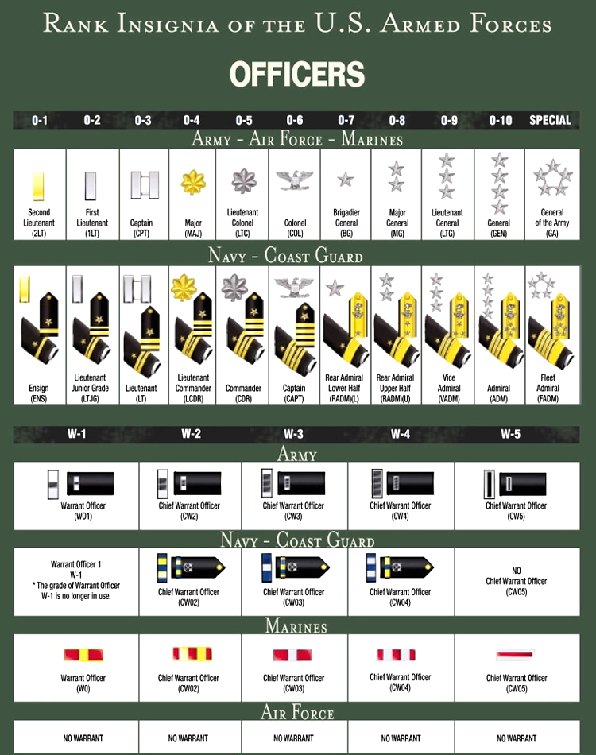

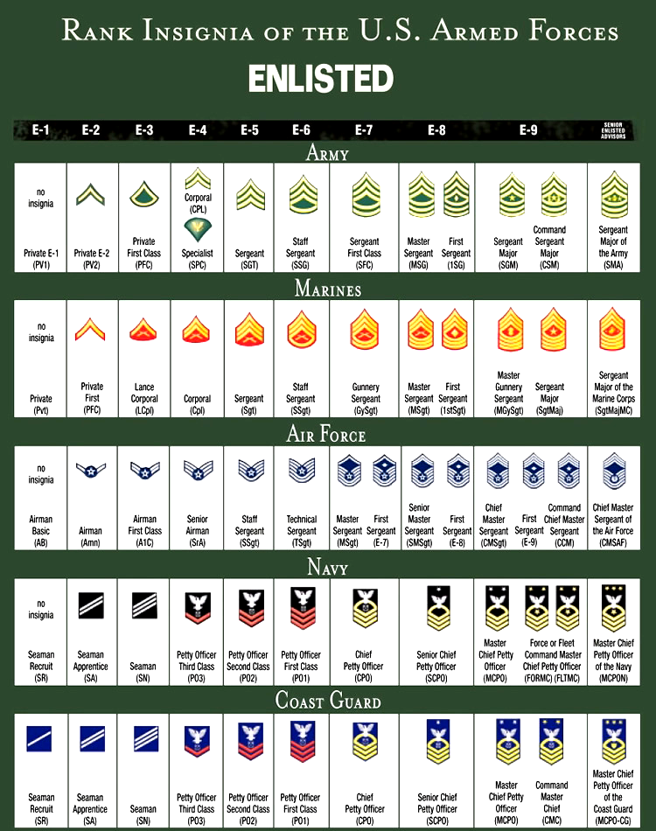

HIGH FLIGHT

By John Gillespie Magee, Jr.
Oh, I have slipped the surly bonds of earth
And danced the skies on laughter-silvered wings;
Sunward I’ve climbed, and joined the tumbling mirth
Of sun-split clouds - and done a hundred things
You have not dreamed of - wheeled and soared and swung
High in the sunlit silence. Hov’ring there,
I’ve chased the shouting wind along, and flung
My eager craft through footless halls of air.
Up, up the long, delirious, burning blue
I’ve topped the windswept heights with easy grace
Where never lark, or even eagle flew.
And, while with silent, lifting mind I’ve trod
The high untrespassed sanctity of space,
Put out my hand, and touched the face of God.

THE CADET’S CREED

I am an Air Force Junior ROTC Cadet
I am connected and faithful to every Corps of Cadets who serve their community and nation with patriotism.
I earn respect when I uphold the Core Values of Integrity First, Service Before Self, and Excellence in All We Do.
I will always conduct myself to bring credit to my family, school, Corps of Cadets, community, and to myself.
My character defines me. I will not lie, cheat, or steal. I am accountable for my actions and deeds.
I will hold others accountable for their actions as well.
I will honor those I serve with, those who have gone before me, and those who will come after me.
I am a Patriot, a Leader, and a Wingman devoted to those I follow, serve, and lead.
I am an Air Force Junior ROTC Cadet.

Keep this guide while in Air Force JROTC.
You will be expected to have it next year.

Replacement cost for lost guide: $5.00

